**Spring Tutorial 01 – Introduction to Spring Framework**

Spring provides 5 frameworks.

1. **Dependency Injection or IOP container or Core-Spring Framework** – Do not create or instantiate an object inside another java class. Instead, rely on Spring’s IOP module to create the object for you.

Any changes to one class will cause other class to be changed.

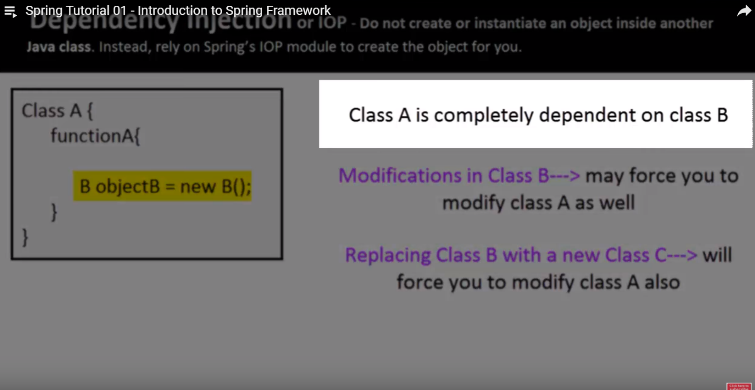

1. **Aspect-oriented programming framework:** Do not mix non-business logic with actual business logic in your classes.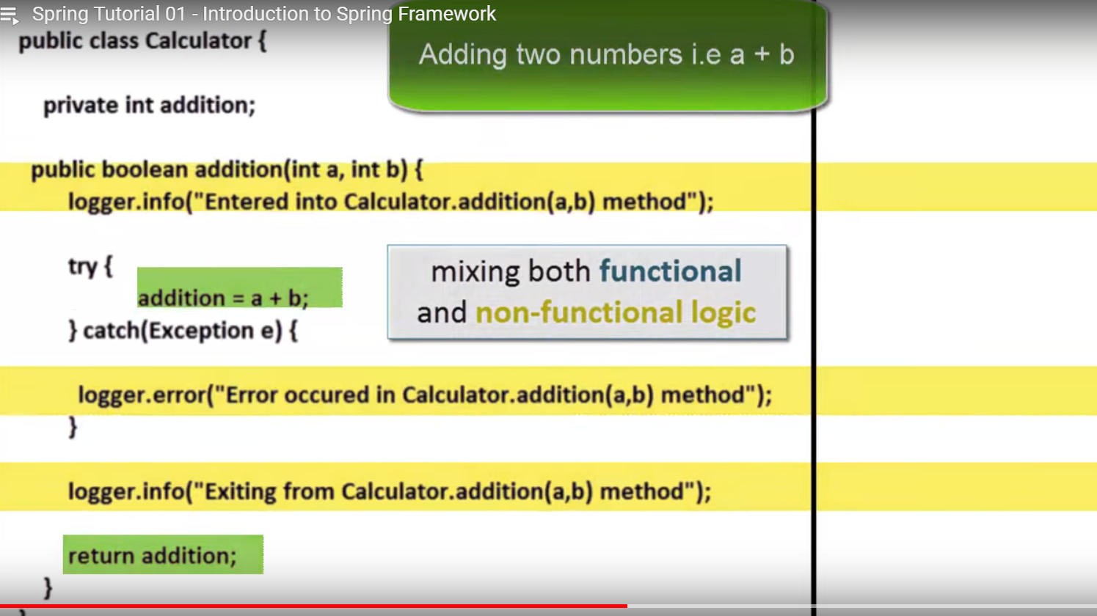
2. **Data Access/Integration Framework:**

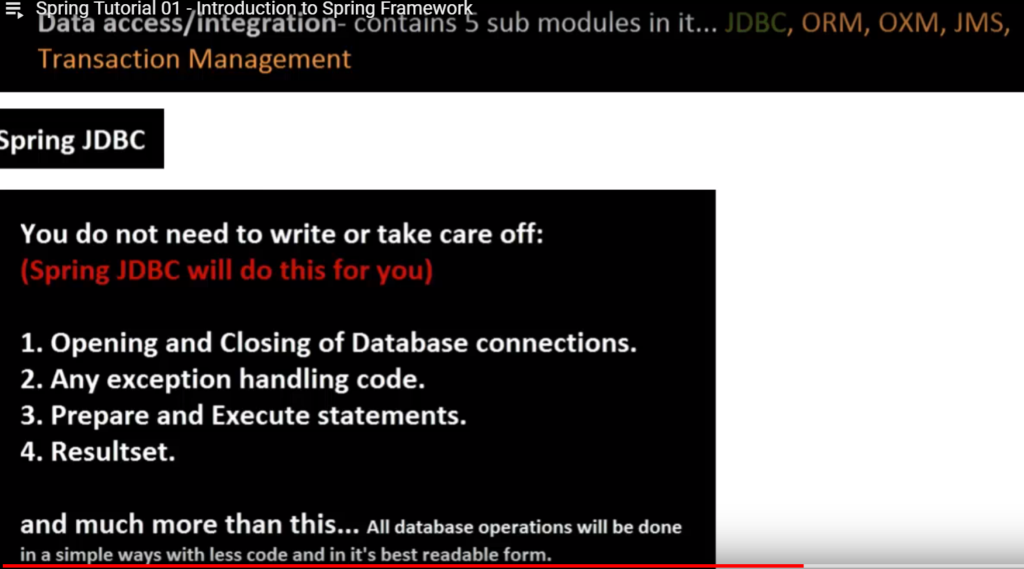

For some reason, if you do not want to use Spring JDBC or plain JDBC, ORM (Object Relation Mapping) module provides full API support to integrate ORM tools like – Hibernate, JPA, IBATIS etc…

Spring OXM – Converting a java object to XML or XML to a java object. It provides full API support to integrate OXM frameworks like – JAXB, Castor, JiBX etc …

Spring JMS – Java Messaging Service. It provides full API support to produce and consume messages from JMS queues.

Spring Transaction Management – provides two ways of Transaction Management - (programmatic way and declarative way)

1. **Model-View-Controller Framework:** Using this, you can build a complete web application using MVC design pattern in very simple ways.
2. **Test Framework:** It provides you with full support for testing Spring components with Junit or TestNG frameworks with lot of ease.

What exactly Spring offers in total: <http://spring.io/projects>

**Spring Tutorial 02**

**Understanding Dependency Injection 01:**

**Problems if you don’t use DI:** 3 major problems.

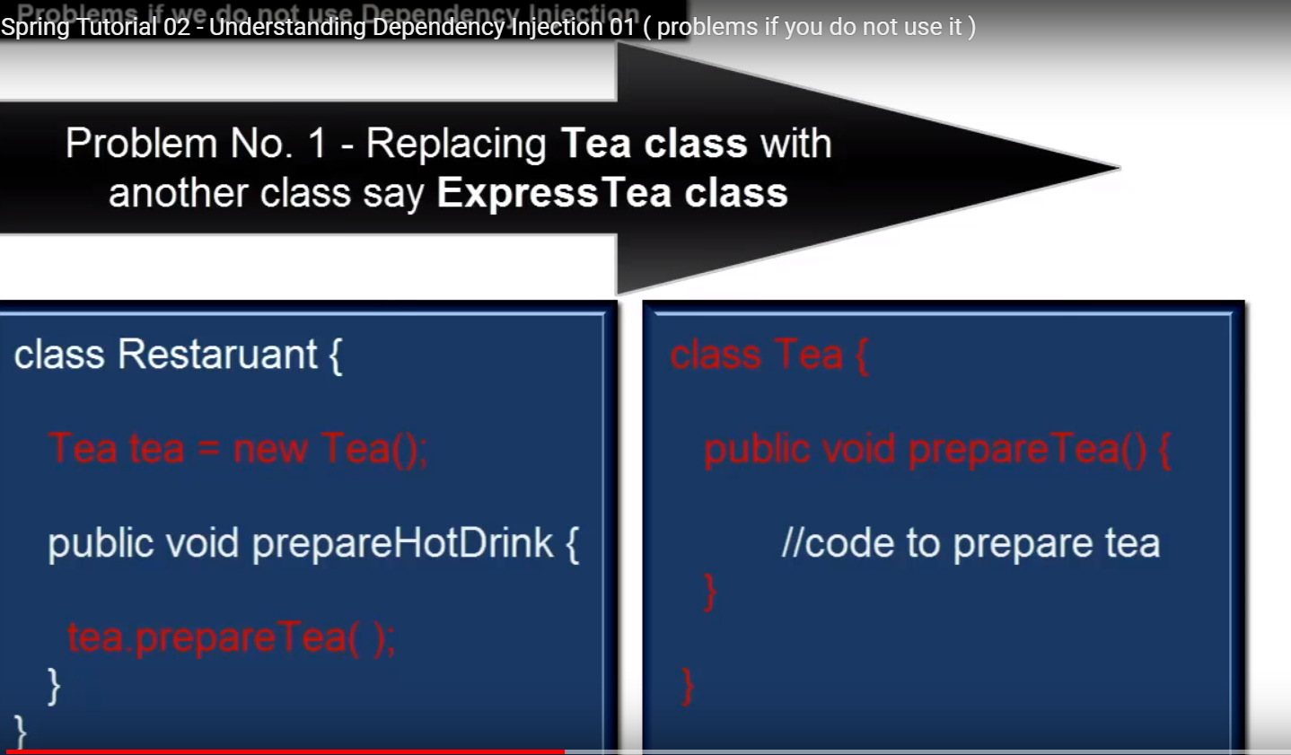

Problem 1: Replacing Tea class with another class say ExpressTea class.

Problem 2: Modifying the Tea class say Parameterizing its constructor.

Problem 3: You cannot test Restaurant class without including Tea class.

All problems are only for one reason – Restaurant class has a direct dependency on Tea class.

If Restaurant class just uses the Tea object without mentioning Tea class anywhere in it – we can overcome all such problems. This can be done using Dependency Injection Framework.

**Dependency Injection Framework** – never create an object inside another class using a new operator.

**Spring Tutorial 03**

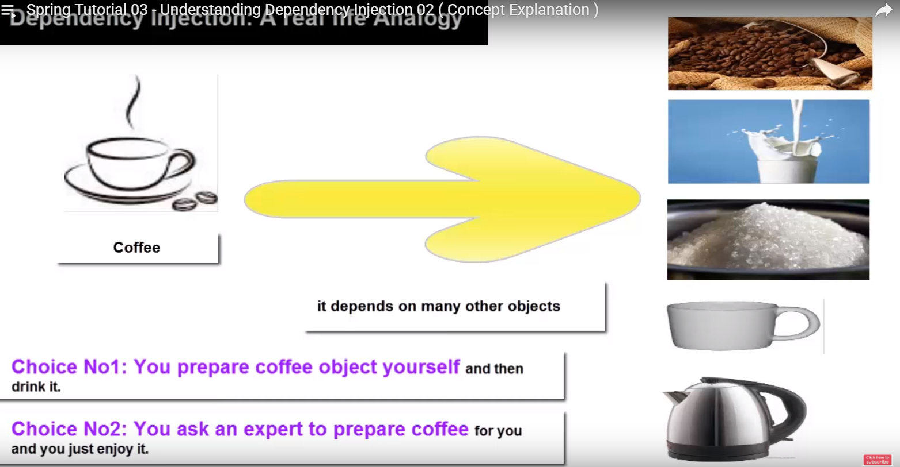

Outsource the task of handling all dependencies of an object to an expert (some third party program)

When the Restaurant object is created, the tea object will be created and provided to it from outside by some third party program.

In order to do this, you need an interface. The interface will bind the Restaurant and Tea class.

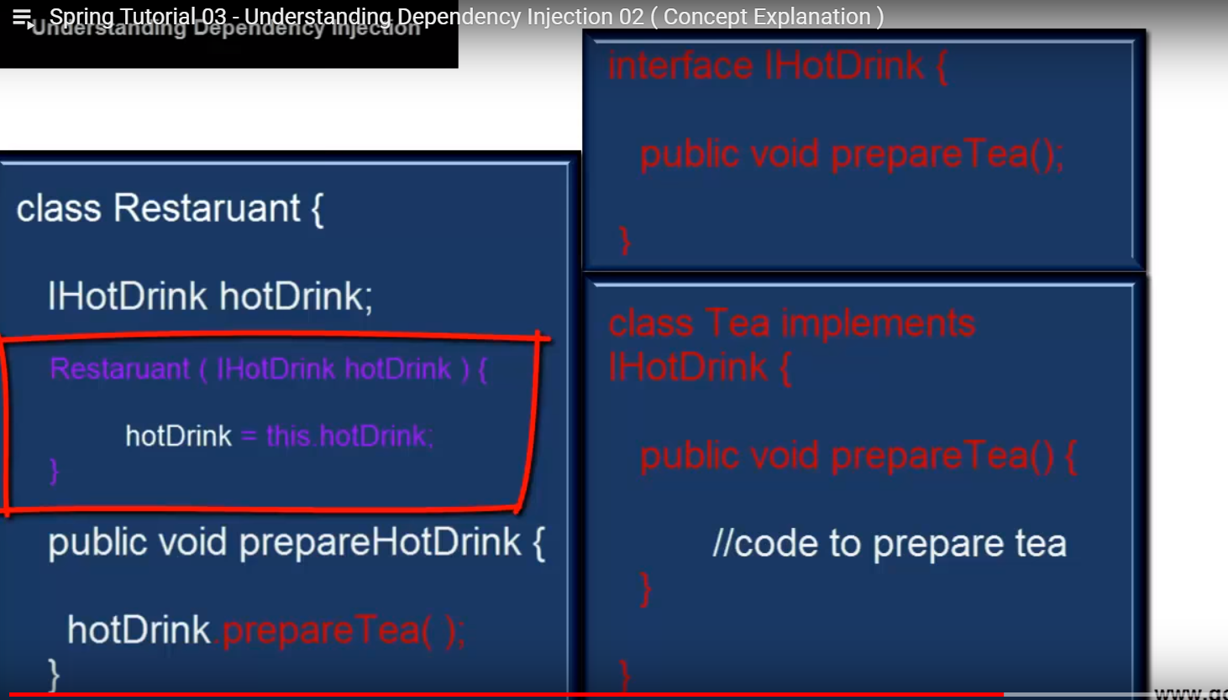

Highlighted box is the constructed method. You may change it with the setting method like shown below:

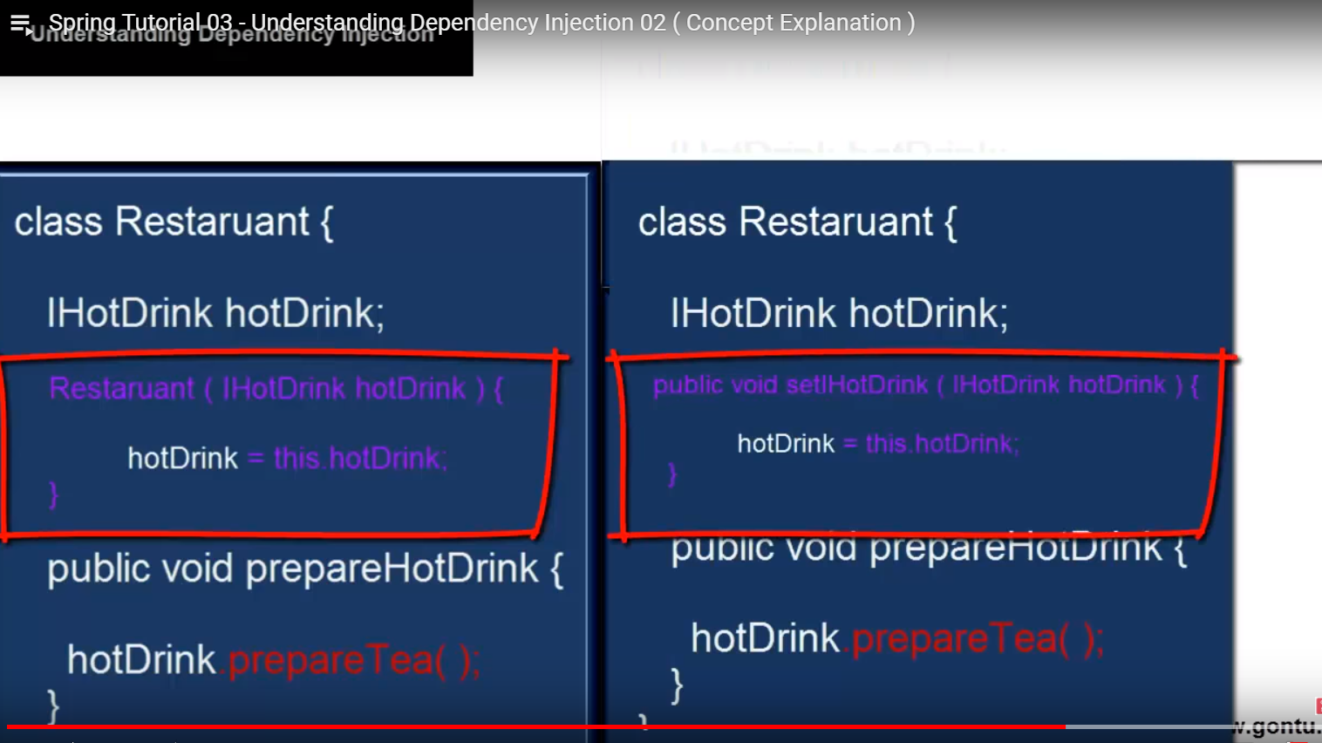

Spring DI Framework provides two ways of DI: 1. Using the constructor way 2. Using the setter method.

**Tutorial 01 – An introduction to MVC framework (MVC Architecture)**

MVC Architecture - Model View Controller

It is simply a guideline which says we should write code for developing an application having a UI.

A web application developed using a servlet technology looks like below:

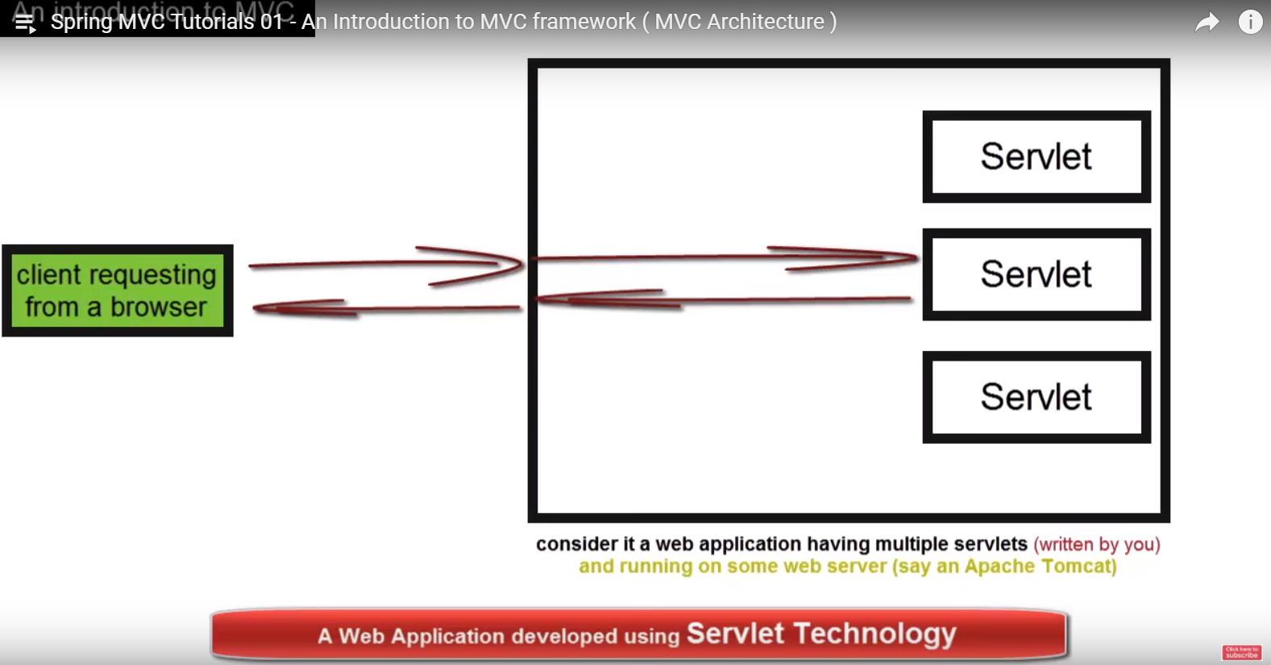

A client requests from a browser, this request is mapped to a particular servlet based on the URL (from among many servlets). This servlet processes the request and sends back the html response to the Client’s browser.

Similarly for JSP Page,

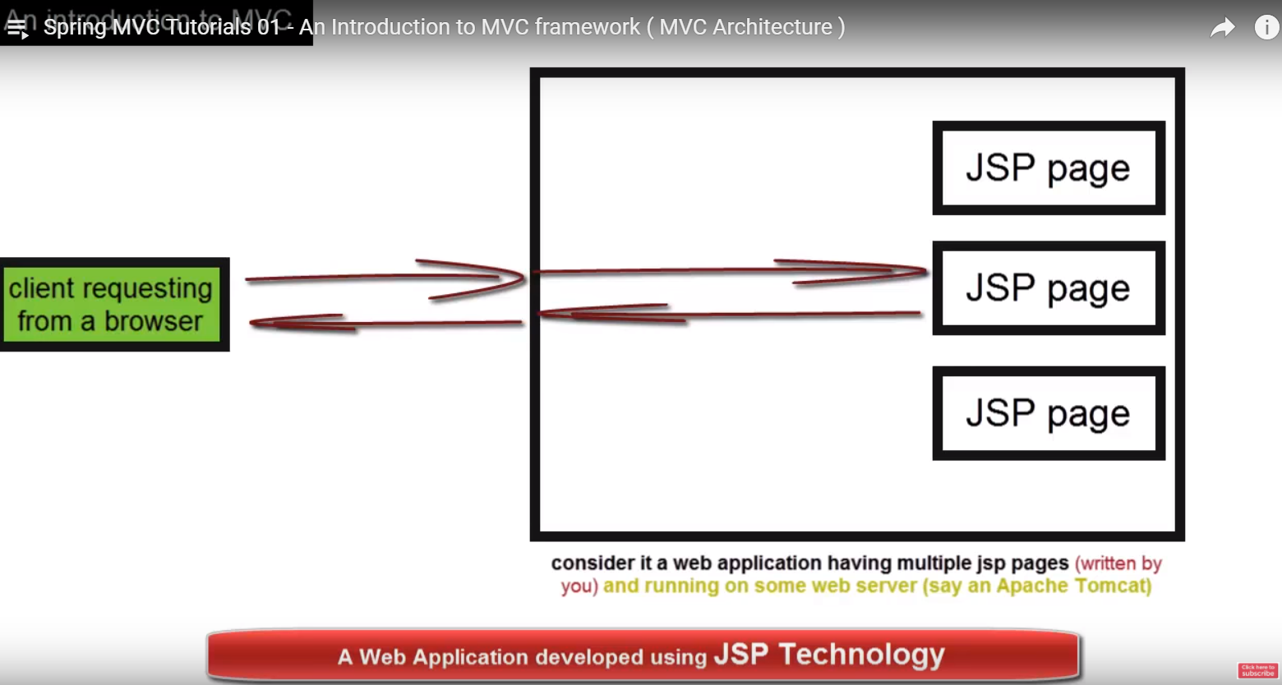

HTML code renders the page and Java code is the logic behind returning the data.

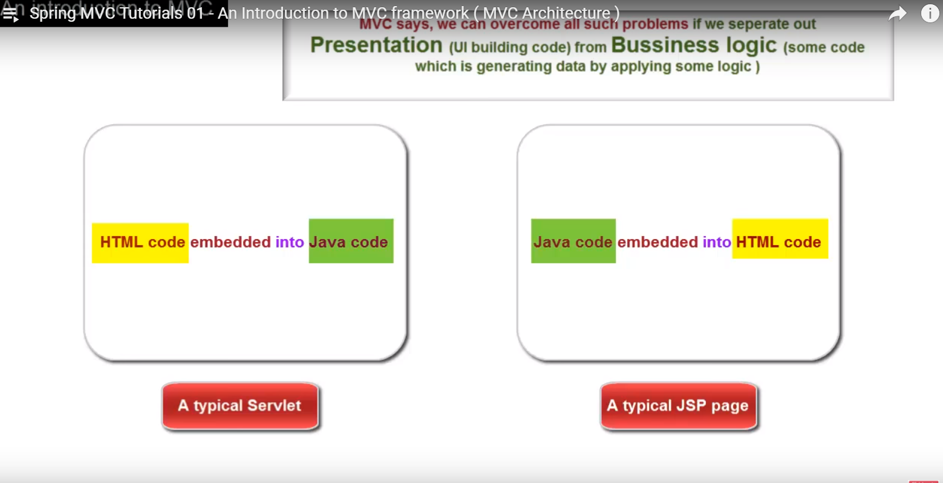

This mixing of java and html code becomes complicated when changes are to be made to the application (Say entire UI change)

MVC says we can overcome all such problems if we separate out Presentation (UI building code) and Business Logic (some code which is generating data by applying some logic).

An application should always be divided into 3 components (M V C):

Model – represents data

View – represents UI

Controller – manages the application flow, makes a call to some sort of service producing Model and then passes on the model to the View.

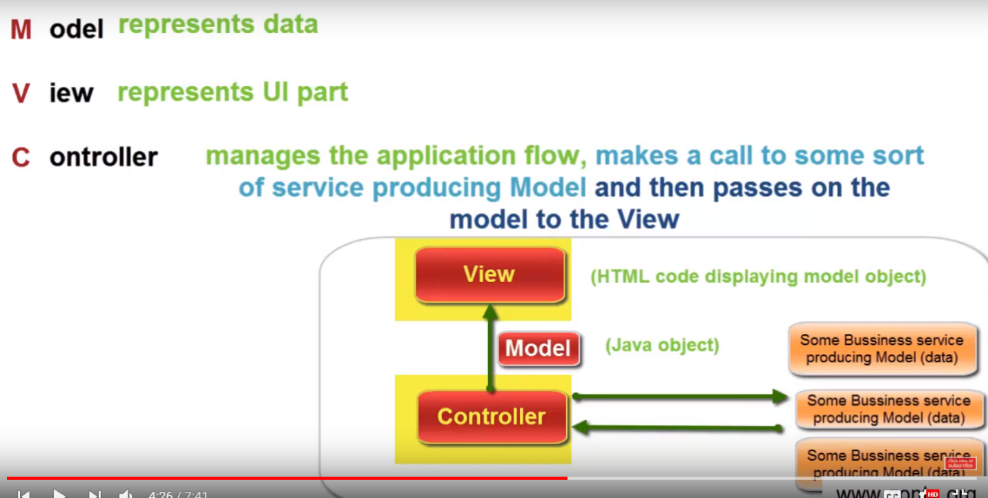

Request comes to the application, the Controller analyzes it and makes a decision to call an appropriate business service to get the Model. Once it receives the Model, it passes it on to the View component inorder to form the final output or response which can be sent back to the Client’s browser.

If you are developing an application using Java, the Model is typically a java object having some properties along with getters and setters method. And typically the View is html code displaying data by retrieving it from the model object. And these business services are also the java objects having some business logic to produce a model object.

Ex:

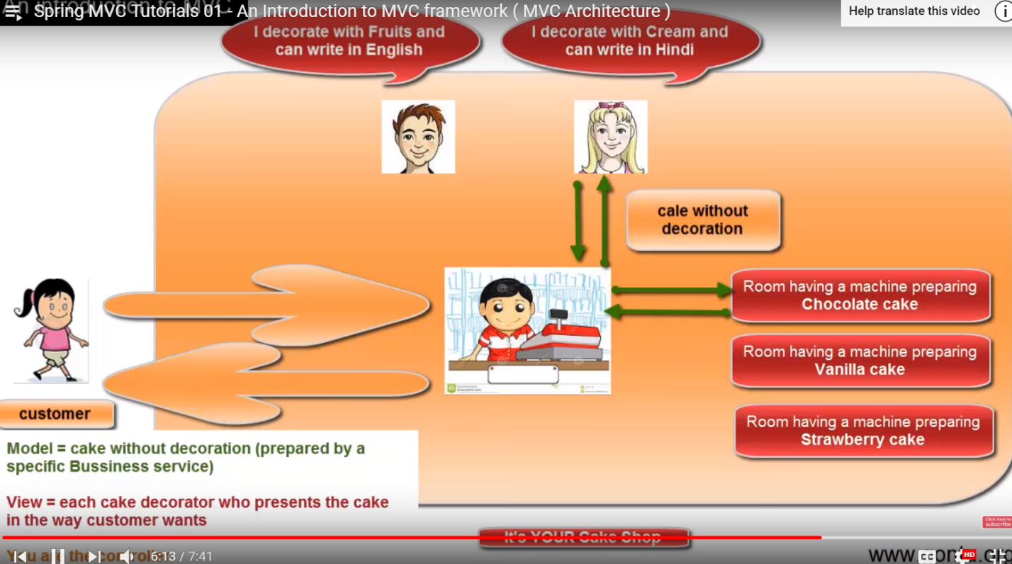

Some definitions of MVC says, “Model is not just the data, it can be any logic too which is generating data (like this - you may find many people speaking different definitions of model, view and a controller).

**Tutorial 02 – An introduction to Spring MVC framework (Spring MVC Architecture)**

Spring MVC is a web development framework (based on MVC guidelines).

Spring MVC is very popular because of its support for “Inversion of control” (or, the Dependency Injection). To understand what is Dependency Injection, see Spring Tutorials 02 and 03.

Consider an application developed using Spring MVC Framework as shown below. When an end user request some web page by entering some URL and hits enter, the request is received by “Front Controller” (this guy controls the complete application flow and has many helpers around to get the work done. Each helper does a specific task and returns the result back to it. With the help of all its helpers, Front Controller’s job is to prepare and send the response i.e., html and data back to its Client’s browser). Immediately after getting request from Client’s browser, Front Controller passes it to one of its helper called “**Handler Mapping**” (it will scan the URL: and tells the exact address of the guy who can generate data for this web page request. Ex: This is like going to someone and asking for the best gift shop and that guy gives you the address of gift shop). Based on the info received from Handler Mapping, Front Controller passes on that request to that specific guy (Data generator guy. Also called “**Controller**”) who is going to generate the data for this specific web page request. The data generator guy prepares the data, creates a Java object to hold this data (it may take help of other Java classes if required to do this job or get the data from the db). Then it returns the Java Object holding data to the Front Controller. In addition to java object, it also sends, name of the component that is going to retrieve data from this Java object along with mixing it with html to prepare the actual response (Ex: The guy went to a store and bought an item. The seller gave him the item and gives him name of the person who gift wraps it but do not know his address). So Front Controller sends a request to another helper guy called “**View Resolver**” (who tells the exact address of this guy to Front Controller)

Now the Front Controller has the Java Object holding the data and the exact address of the guy (Final Response Builder Guy or “**View**") who is going to generate the actual response which is to be sent to the Client’s browser. So Front Controller sends the Java object to “Final Response Builder Guy” and it simply retrieves the data from the Java Object and puts it into the html code in the desired fashion and returns it to the Front Controller. The Front Controller now sends this as the response to the Client’s browser.

Front Controller is also called as Dispatcher Servlet in an MVC Framework.

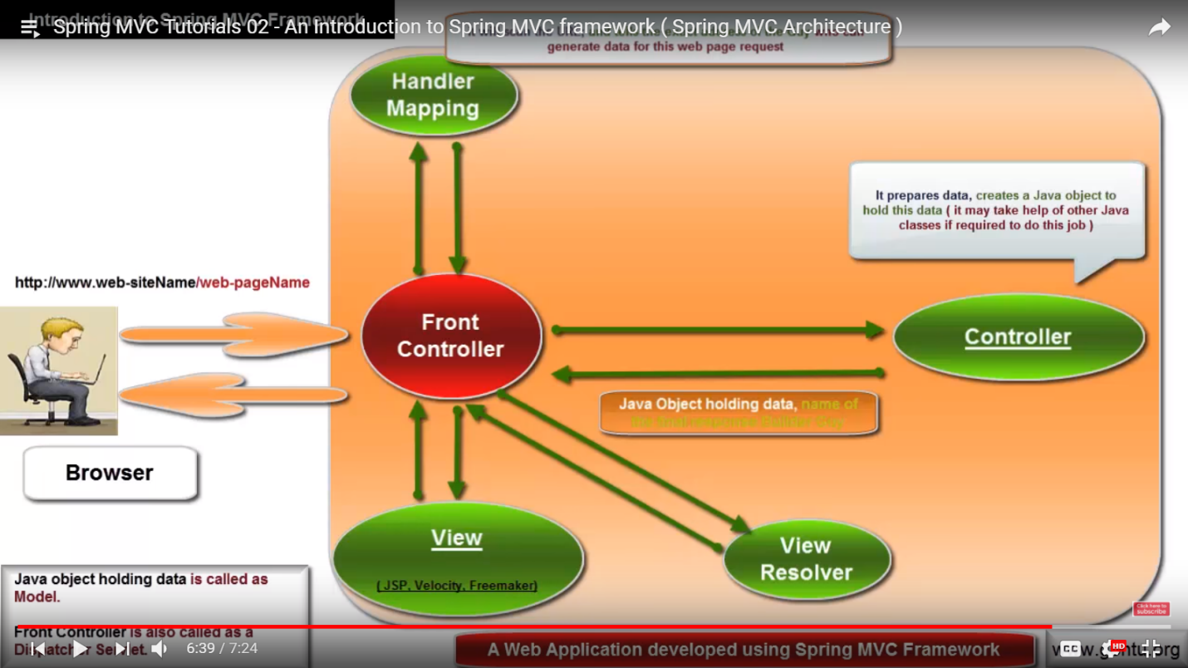

**Spring MVC Tutorials 03 – Installation and Setup using an Eclipse IDE**

I am downloading all softwares and tools in location: “C:\Spring-MVC”

Download Eclipse -> Right click on Enterprise Explorer and create a new dynamic web project -> Name=MyFirstSpringMVCProject -> Next -> Next -> select “Generate web.xml deployment descriptor” -> Finish.

Now to use Spring MVC Framework, we need to have spring related jars onto the projects class path.

You can download spring distribution zip containing all required jars from this link: <http://repo.spring.io/release/org/springframework/spring/>

Download ([spring-framework-5.0.2.RELEASE-dist.zip](http://repo.spring.io/release/org/springframework/spring/5.0.2.RELEASE/spring-framework-5.0.2.RELEASE-dist.zip)) and extract it -> Copy all jars inside “libs” directory and paste it in Eclipse (WebContent -> WEB-INF -> lib)

Here, you will find exact dependencies information for the MVC project if you are going to use Maven or Gradle: <http://projects.spring.io/spring-framework/> (this is not needed if I am downloading it manually)

You may download commons-logging.jar from this link: <http://commons.apache.org/proper/commons-logging/download_logging.cgi>

Download and extract. Copy “commons-logging-1.2.jar” and paste it in Eclipse (WebContent -> WEB-INF -> lib)

Lastly we would need a web server supporting servlet jsp technologies. Ex: Tomcat Apache Server, Weblogic, Websphere, JBoss, etc… We will use Tomcat Apache Server

**Steps to download and install Apache Tomcat Server:**

1. Go to the website <http://tomcat.apache.org/download-70.cgi>

And, download the relevant Tomcat Apache Zip for your computer.

(Select the zip to download based on the operating system you use e.g windows, unix based etc. and also based on whether it is a 32 bit or a 64 bit operating system. It is always recommended to download the latest stable version of the server from the website.)

1. Unzip the contents (which you downloaded in the first step) in your local drive say d:/drive

Only step pending here is to integrate Tomcat Apache Server with project in an Eclipse IDE so that once you are done developing web application using Spring MVC Framework, you should be able to run it on the server from within an Eclipse IDE

**Spring MVC Tutorials 04 – Integrating Tomcat Apache Server with an Eclipse IDE**

Eclipse -> Windows -> Show View -> Other -> Server -> Server -> Click on the link to find a new server from the list (which you want to use to run your web application) -> select “Tomcat v9.0 Server” -> Next -> Specify Tomcat installation directory (path of the tomcat folder which contains bin folder)

Right click on the project name -> Properties -> Targeted Runtimes -> select “Apache Tomcat v7.0” -> Ok

**Spring MVC Tutorials 05 – Creating first Spring MVC Web Application using Eclipse**

I just need to follow these 4 simple steps to create a basic web application using Spring MVC:

1. Modify web.xml file
2. Create spring-dispatcher-servlet.xml
3. Create the HelloController.java class (A controller)
4. Create the HelloPage.jsp file (A view)

Web.xml should always be present inside WEB-INF (in Eclipse). Its main purpose is to map the input URL to the appropriate servlet which can serve the request.

The reason we are talking about Servlet is because Spring MVC is using Servlet technology as its base.

If you don’t know how to write servlets and want to use Spring MVC then include below code in web.xml

Step 1:

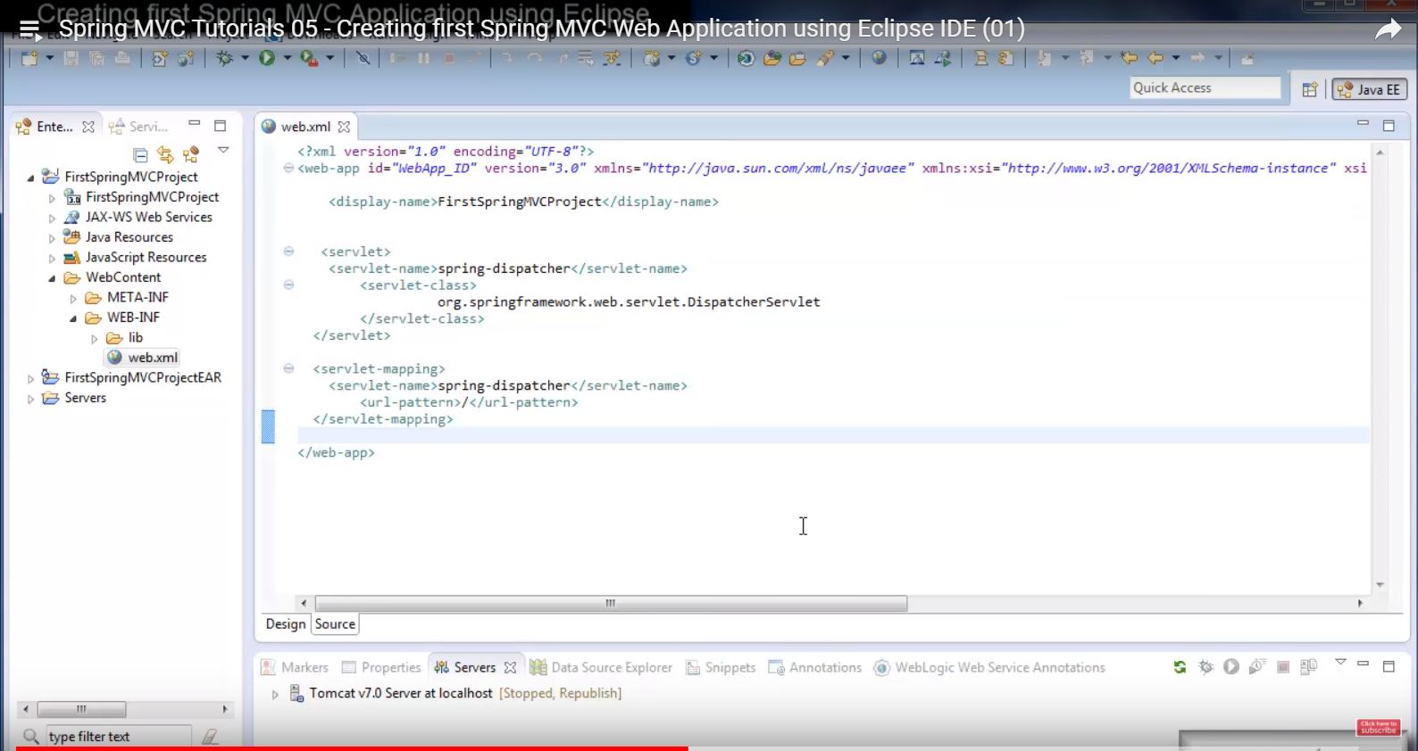

This code is simply telling servlet technology that all URL requests to the web application should be mapped to Spring MVC framework for further processing. “DispatcherServlet” is also called as “Front Controller” which takes complete responsibility of processing the URL request and sending back the response to the Client’s browser.

In order to make Front Controller (DispatcherServlet) work and take charge of controlling the overall application, we will need to provide all relevant information to it in a file called as spring-dispatcher-servlet.xml

Step 2:

Right click on “WEB-INF” -> New file -> Name = “spring-dispatcher-servlet.xml” -> Finish

Write below code

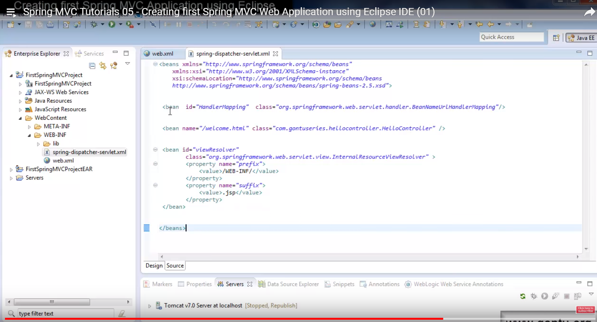

It has 3 sections.

Section 1: <bean id="HandlerMapping" class="org.springframework.web.servlet.handler.BeanNameUrlHandlerMapping"/>

This section tells Front Controller which Handler Mapping (whose job is to just scan the input URL and tell Front Controller which data generator class to be called for further processing that request) to use.

Section 2:

<bean id=*"viewResolver"*

class=*"org.springframework.web.servlet.view.InternalResourceViewResolver"* >

<property name=*"prefix"*>

<value>WEB-INF</value>

</property>

<property name=*"suffix"*>

<value>.jsp</value>

</property>

</bean>

This section tells Front Controller which View Resolver (whose job is to just tell the exact location of the view present in the project) to use.

Section 3: <bean name="/welcome.html" class="com.gontuseries.hellocontroller.HelloController" />

This is the Controller OR the data generator class.

Step 3: Write HelloController.java

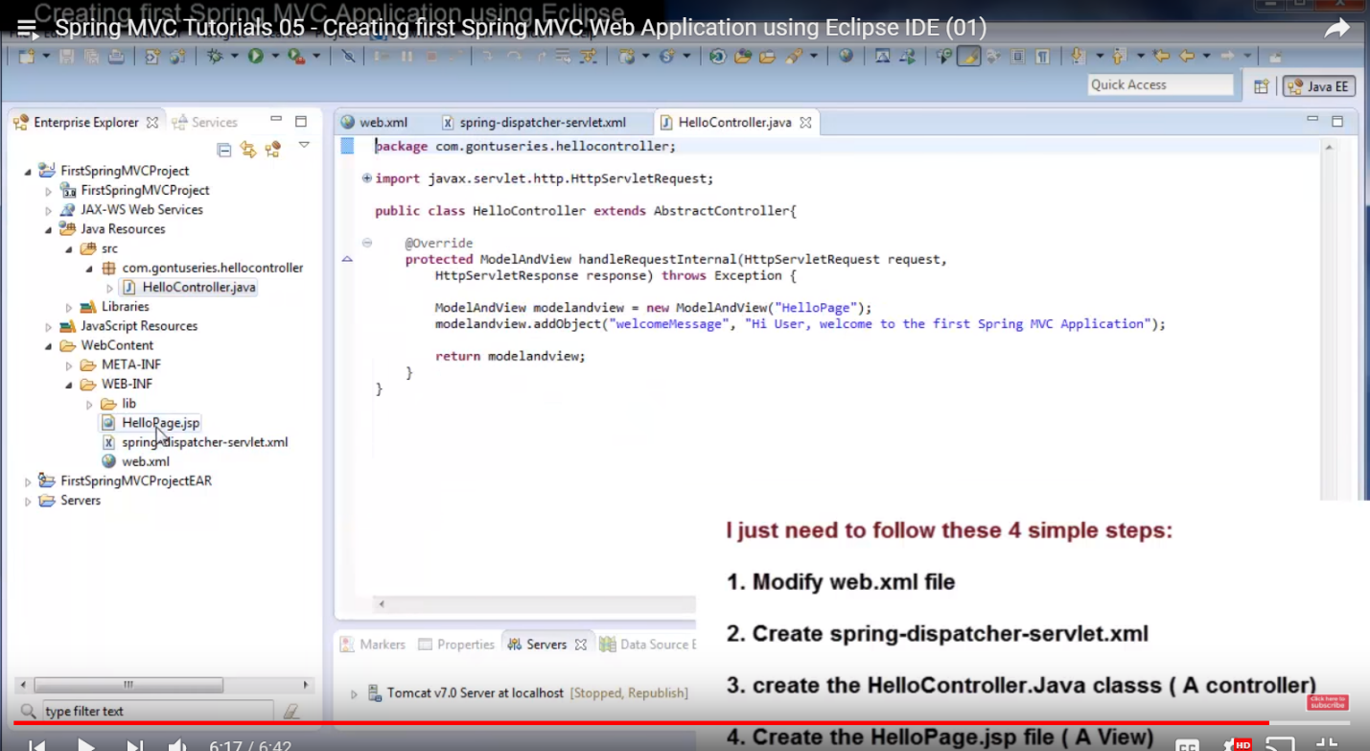

Step 4: Write HelloPage.jsp

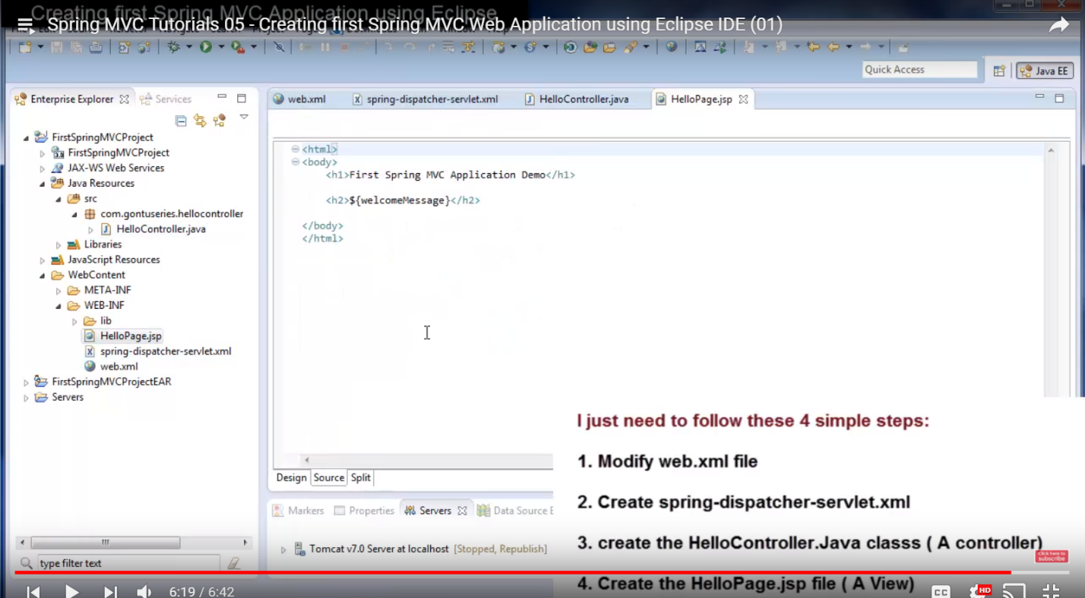

**Spring MVC Tutorials 06 – Creating first Spring MVC Web Application using Eclipse IDE (02)**

When the Client requests for a URL (<http://localhost:8080/FirstSpringMVCProject/welcome.html>), the Servlet technology would map this URL request to DispatcherServlet (in web.xml) provided by Spring MVC framework. The DispatcherServlet would read a file named “spring-dispather-servlet.xml” and would further control the application based on what we have written in that file.

There are many handlermapping classes provided by Spring MVC Framework. The basic one (BeanNameUrlHandlerMapping) is being used above.

Below is how viewResolver identifies the view resolver (It identifies the view by prefix and suffix).

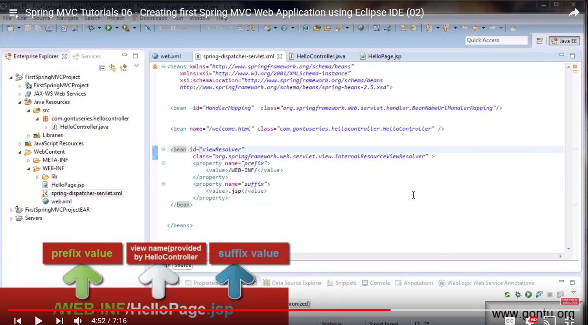

There are many viewResolver classes provided by Spring MVC. The basic one (InternalResourceViewResolver) is used above.

To run: Right click on project (FirstSpringMVCProject) -> Run As -> Run on Server

Once it runs successfully on server (it will return 404 in Eclipse but that’s ok). Then try hitting URL (<http://localhost:8080/FirstSpringMVCProject/welcome.html>) from browser and see if it returns the content.

**Sprint MVC Tutorials 07 – writing an annotation based controller class - @Controller, @RequestMapping**

Spring MVC says there are 2 ways of writing controller class in your application. One is without annotations and another is with Spring MVC provided annotations. In above class, we did it without using annotation. Now we will write the same controller class using annotations.

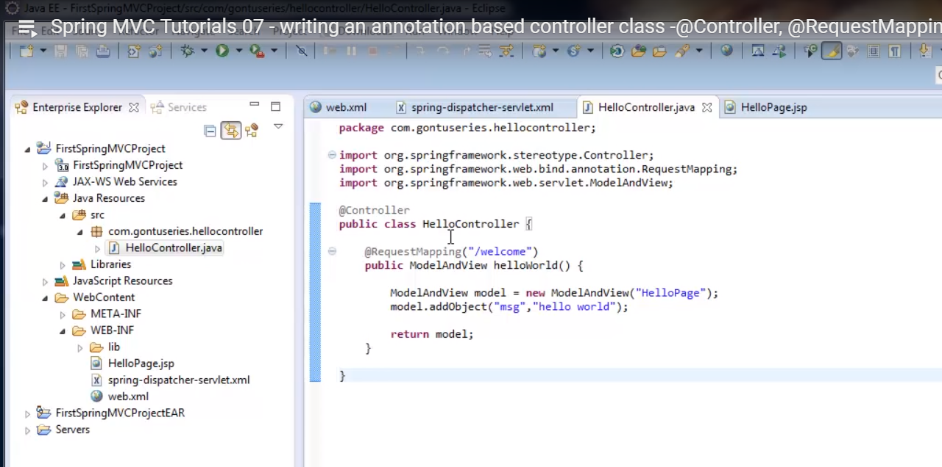

If we write “@Controller” on top of a class then Spring MVC will consider it as a Controller class. There are 2 benefits of this: 1) we do not need to extend HelloController class from any specific based classes or implement any specific interfaces. 2) we do not need to put an entry (for this class) for the controller and HandlerMapping in spring-dispatcher-servlet.xml file. So below two lines from the xml file can be removed.

<bean name=*"/welcome.html"* class=*"com.gontuseries.hellocontroller.HelloController"* />

<bean id=*"HandlerMapping"* class=*"org.springframework.web.servlet.handler.BeanNameUrlHandlerMapping"*/>

To make better use of this: Replace above lines with below line.

<context:component-scan base-package=*"com.gontuseries.hellocontroller"* />

This means that we are telling Spring MVC framework: Automatically detect all java classes having controller annotations written in them which are placed in package: “com.gontuseries.hellocontroller”. And also do consider all of them as if I have put their entries in this xml file.

If we do not write above statement then we’ll need to put an entry of every single controller class in this file. This will just make our code clean and less number of lines of code.

What is @RequestMapping:

When the request from Client’s browser comes to web.xml file, it is mapped to the DispatcherServlet of Front Controller of Spring MVC Framework. The Front Controller reads spring-dispatcher-servlet.xml file for further processing the request. After it reads the line “context:component…….”, it understands that we have used annotation based classes in this package so it loads all the controller classes in its memory. Now it has to decide, which controller method to invoke for further processing the request. The way it does is,

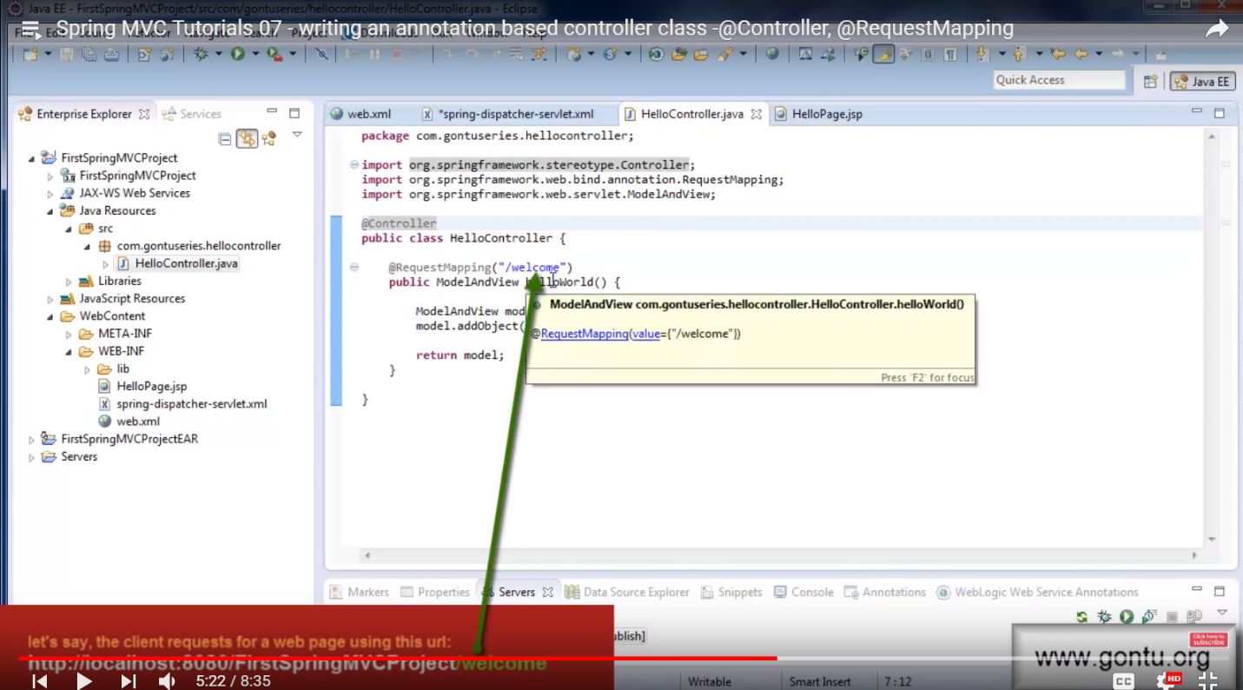

This method would simply prepare the ModelAndView object which is having the data to be displayed on the response web page. This object is sent back to the Front Controller. The view name which Front Controller would use to prepare the response is “HelloPage”.

The Front Controller would now find out the exact path of the view which is present in the project using the “viewResolver” class as shown below.

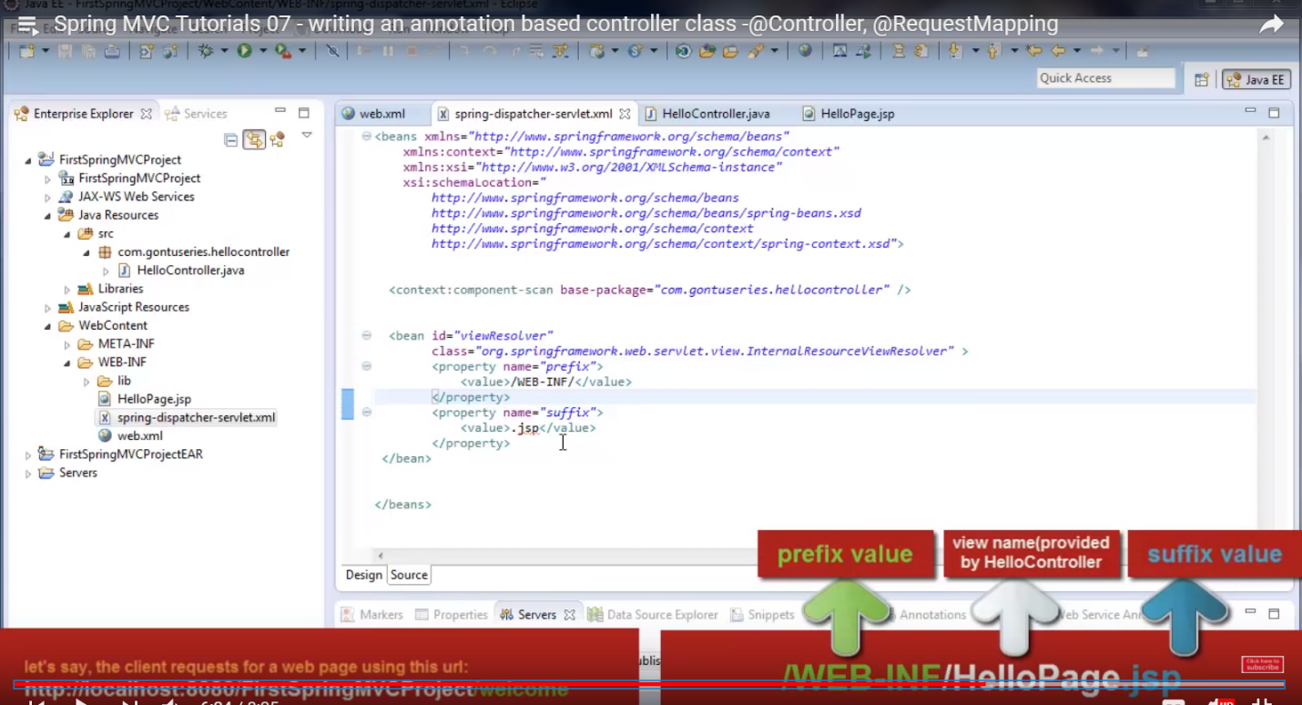

HelloPage.jsp file would simply mixes the data which HelloController.java has provided to it along with the html code and prepares the response using this mixture and sends it back to Front Controller which in turn sends it to the Client’s browser.

Run it and you should see similar response on the Client’s browser as that without annotation.

**Spring MVC Tutorials 08 – MultiAction Controller Class, @RequestMapping at class level**

MultiAction Controller Class – If a class has more than one request handler mapping method (multiple methods like @RequestMapping(“/welcome”), @RequestMapping(“/hi”)

Ex:

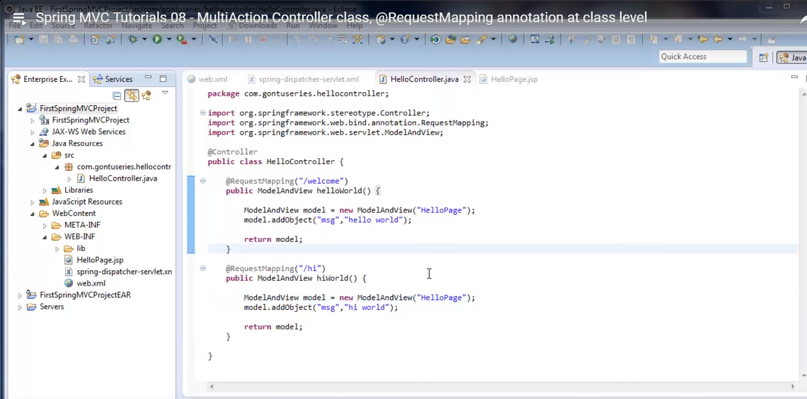

If a user requests: <http://localhost:8080/FirstSpringMVCProject/welcome> then request is mapped to “@RequestMapping(“/welcome”)”

If a user requests: <http://localhost:8080/FirstSpringMVCProject/hi> then request is mapped to “@RequestMapping(“/hi”)”

But if a user requests: <http://localhost:8080/FirstSpringMVCProject/abcdefgh> (which do not match with request handler mapping methods) then the application will return a response (404 error) saying there is no available resource on the server which can process this request.

If you write, “@RequestMapping(“/greet” on top of the class then request URL “<http://localhost:8080/FirstSpringMVCProject/welcome>” then it will return resource is not available (404 Error). Because now the request should look like <http://localhost:8080/FirstSpringMVCProject/greet/welcome> OR <http://localhost:8080/FirstSpringMVCProject/greet/hi>

**Spring MVC Tutorials 09 - @PathVariable annotation in detail (A URI-Template concept)**

If the patterns are different then Front Controller cannot find the requested resource.

Ex:

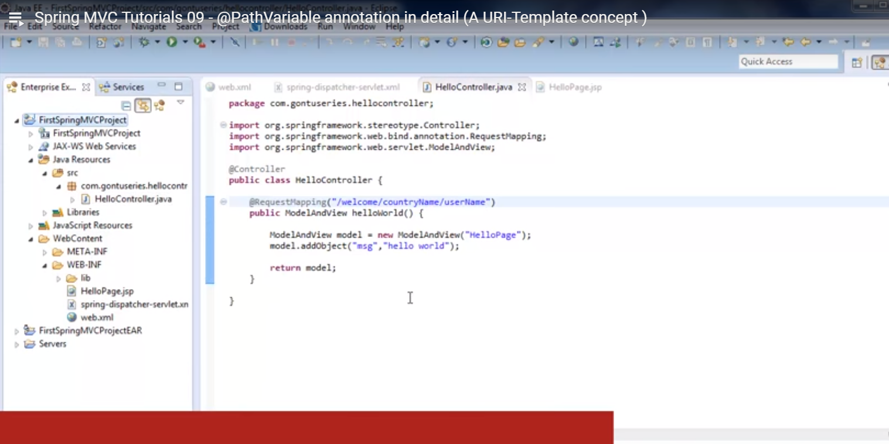

For URL: <http://localhost:8080/FirstSpringMVCProject/welcome/countryName/gontu1>, it will return 404 error because there is a mismatch between “gontu1” string and “username” string.

To allow substitution of “username” with any username then use curly braces as shown below:

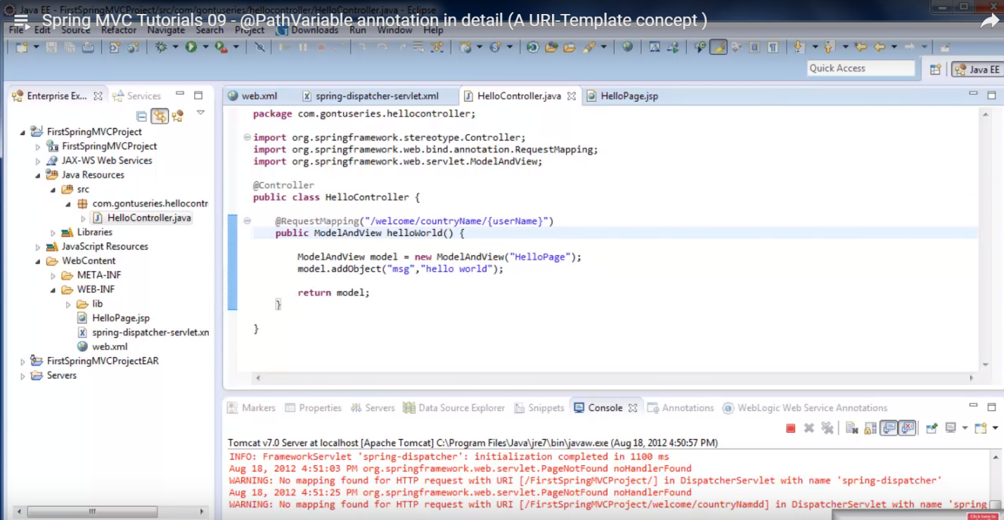

Now the URL: <http://localhost:8080/FirstSpringMVCProject/welcome/countryName/gontu1> should return the desired response.

Now if I want to retrieve the {username} value coming from the incoming request URL, I should use path annotation. This is shown below.

public ModelAndView helloWorld(@pathVariable(“username”) String name) {

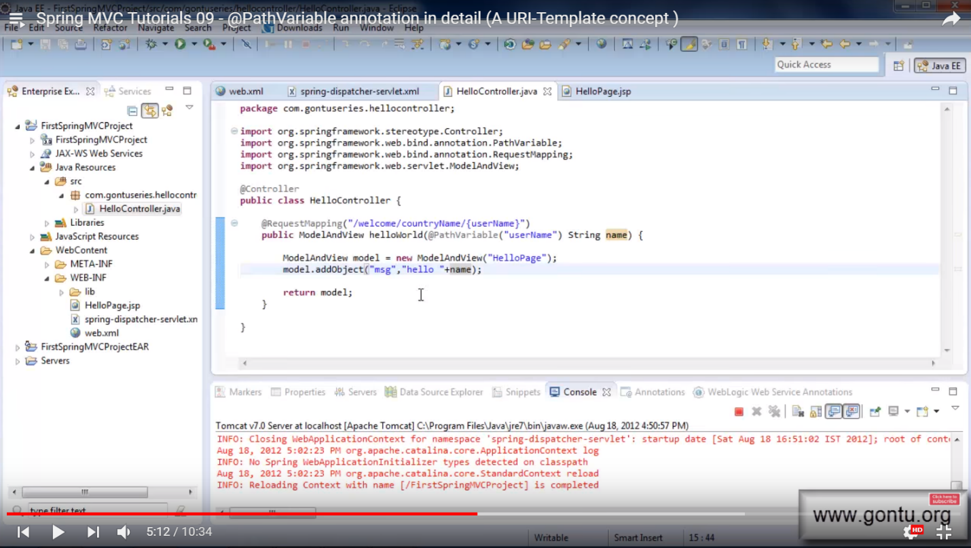

This means that we are telling spring framework, when the Front Controller would invoke HelloController method then bind the {username} value (which is coming from incoming request URL) with the String variable “name” and I should be able to use that value further in the method using this “name” variable.

Check this out by going to URL: <http://localhost:8080/FirstSpringMVCProject/welcome/countryName/gontu1>

Exp Resp:

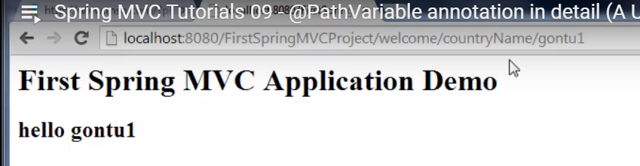

Now if I want to do the same thing with countryName (pass countryName value in URL and use it in method) then do below:

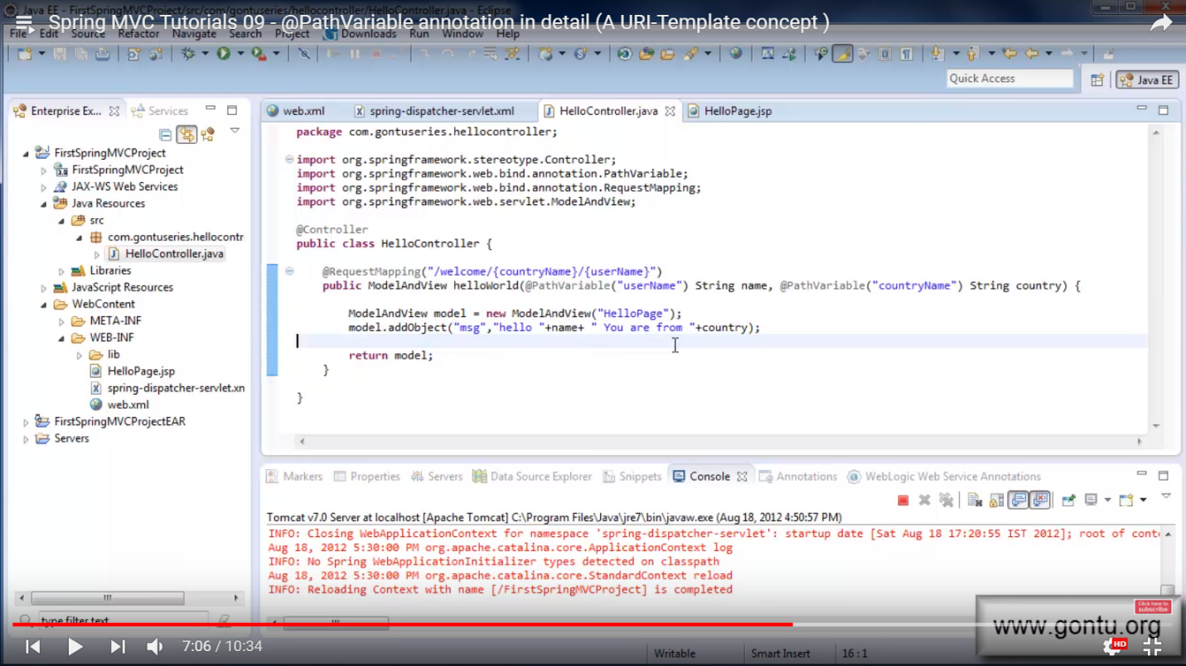

Exp Resp:

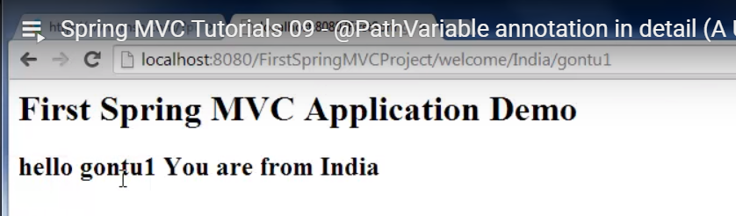

If there too many arguments then use the Map as shown below. Also we have to modify the spring-dispather-servlet.xml file (include line: <mvc:annotation-driven/>). This is shown below:

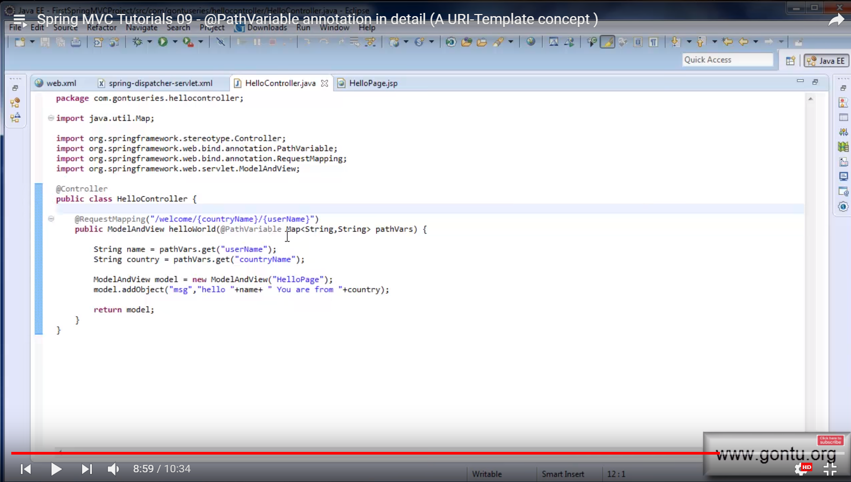

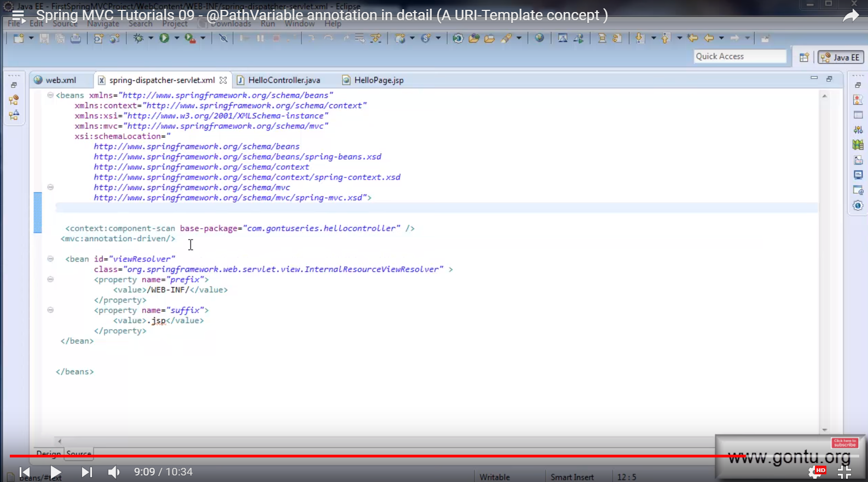

**Spring MVC Tutorials 10 – Handling an HTML form using @RequestParam annotation**

When you enter, <http://localhost:8080/FirstSpringMVCProject/admissionForm.html>, it should return below

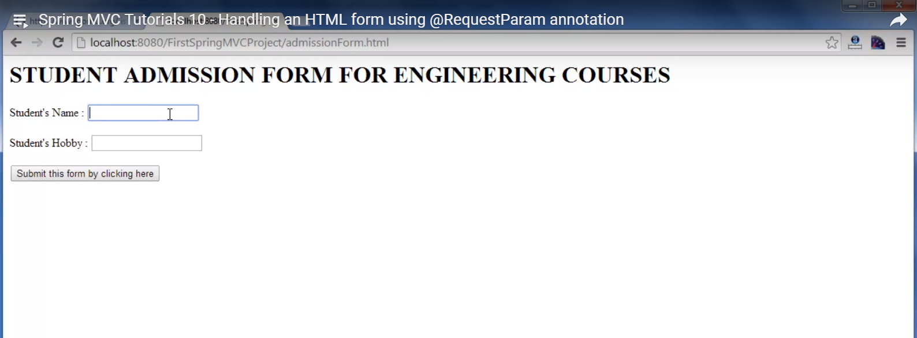

When you enter the name and hobby and click on that button, it should return a confirmation message.

For this, write the “StudentAdmissionController.java” class, AdmissionForm.jsp, AdmissionSuccess.jsp as shown below:

**StudentAdmissionController.java**

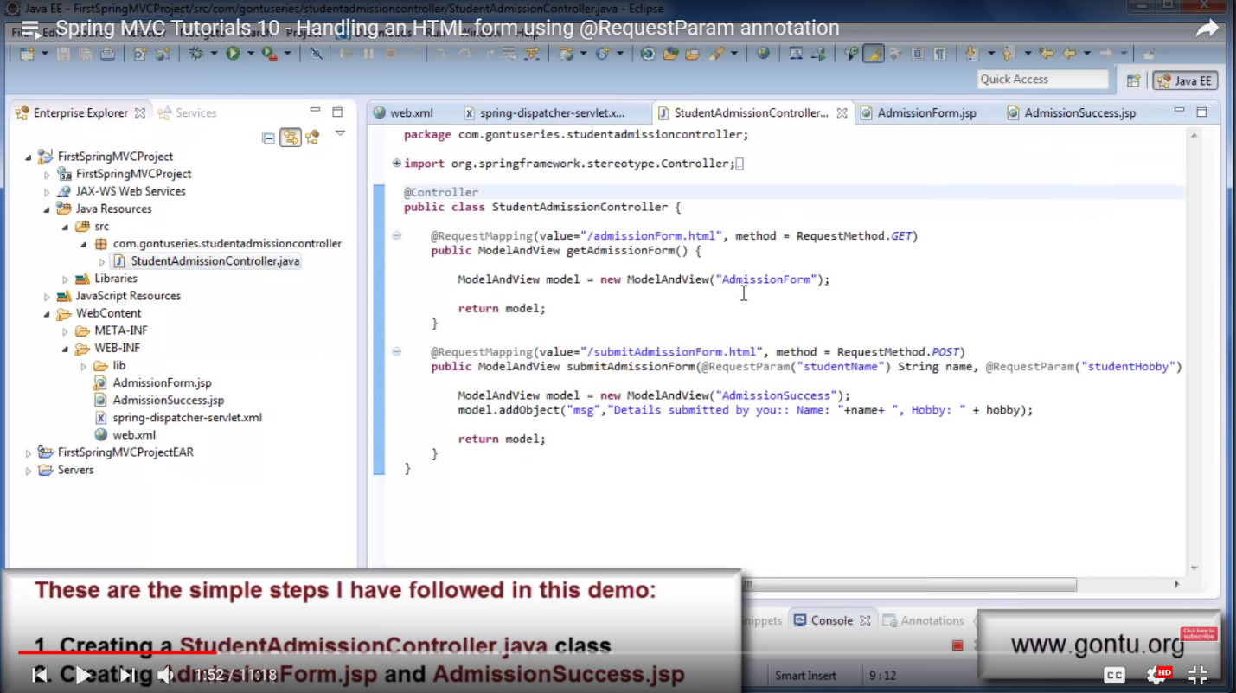

When the user requests the URL (<http://localhost:8080/FirstSpringMVCProject/admissionForm.html>), the request reaches StudentAdmissionController.java class. Now, how the Front Controller will decide which method to use is by analyzing 2 things: 1) The pattern of URL (value=”/admissionForm.html”). And 2) “method = RequestMethod.GET” means it is a GET request.

The Front Controller would then forward the request to “AdmissionForm.jsp” file. (How does it do that ? And: With the help of viewResolver class)

Now when the Controller reaches AdmissionForm.jsp file, it prepares the response using below html code:

**AdmissionForm.jsp**

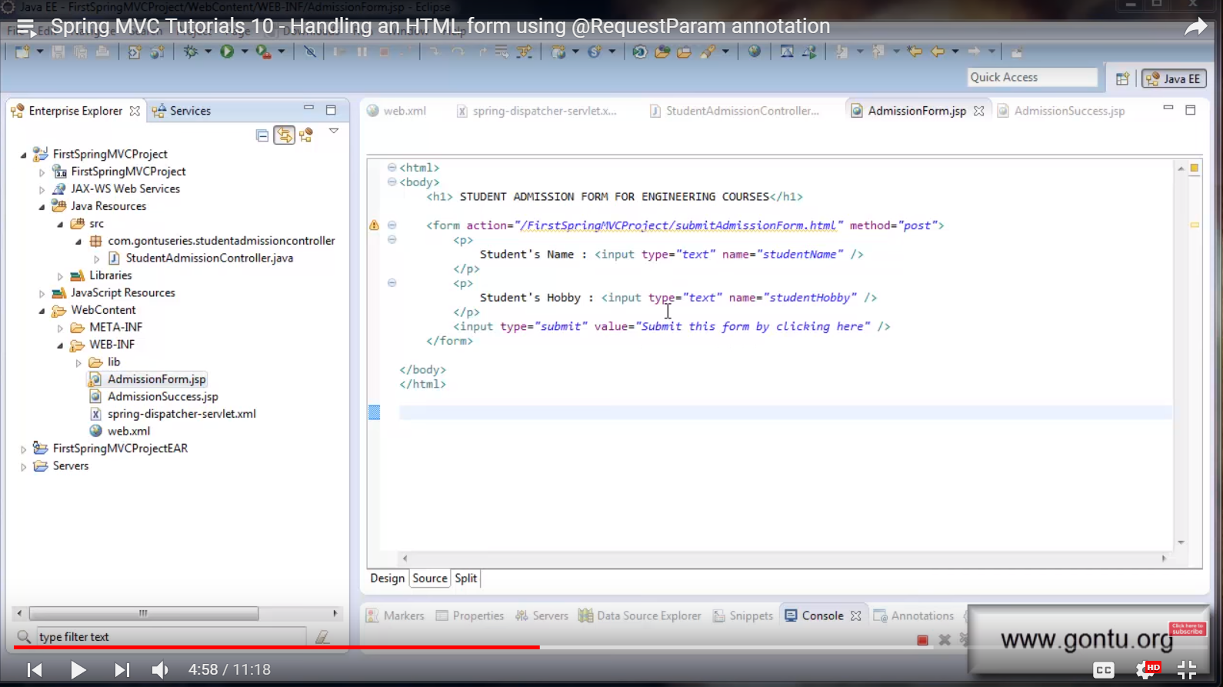

Note that the method here is “post”.

This jsp file would prepare and send back the response to Front Controller which in-turn would send this response back to the Client’s browser.

Now when the Client enters name and hobby and clicks on button “Submit”, the request will again reach to StudentAdmissionController.java class and this request is of http POST type (we defined it as post method in admissionForm.jsp file). This time it will invoke “submitAdmissionForm” method (How ? Ans: This is because of the post method and the URL as shown above in “AdmissionForm.jsp” file)

Imp: When the Client enters the form on the browser, we’ll send values of two request parameters (studentName and studentHobby) to the application along with the request. This is done using @RequestParam as shown below (in StudentAdmissionController.java class):

“public ModelAndView submitAdmissionForm(@RequestParam(“studentName”) String name, @RequestParam(“studentHobby”) String hobby) {“

The submitAdmissionForm method prepares and sends back the response to Front Controller which would forward the request to the AdmissionSuccess.jsp file (with the help of viewResolver class)

**AdmissionSuccess.jsp**

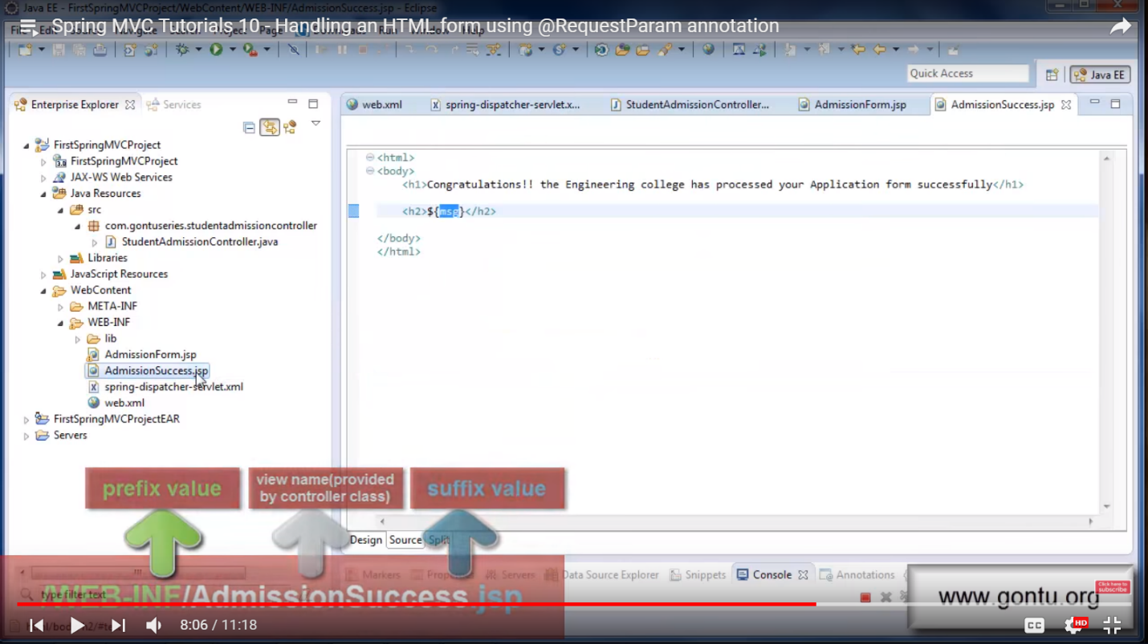

This jsp file would send this message back to the Front Controller which in-turn sends back to the Client’s browser.

Now when the Client only enters hobby but not the student name and click on the button, the application is returning null value for student name as shown below

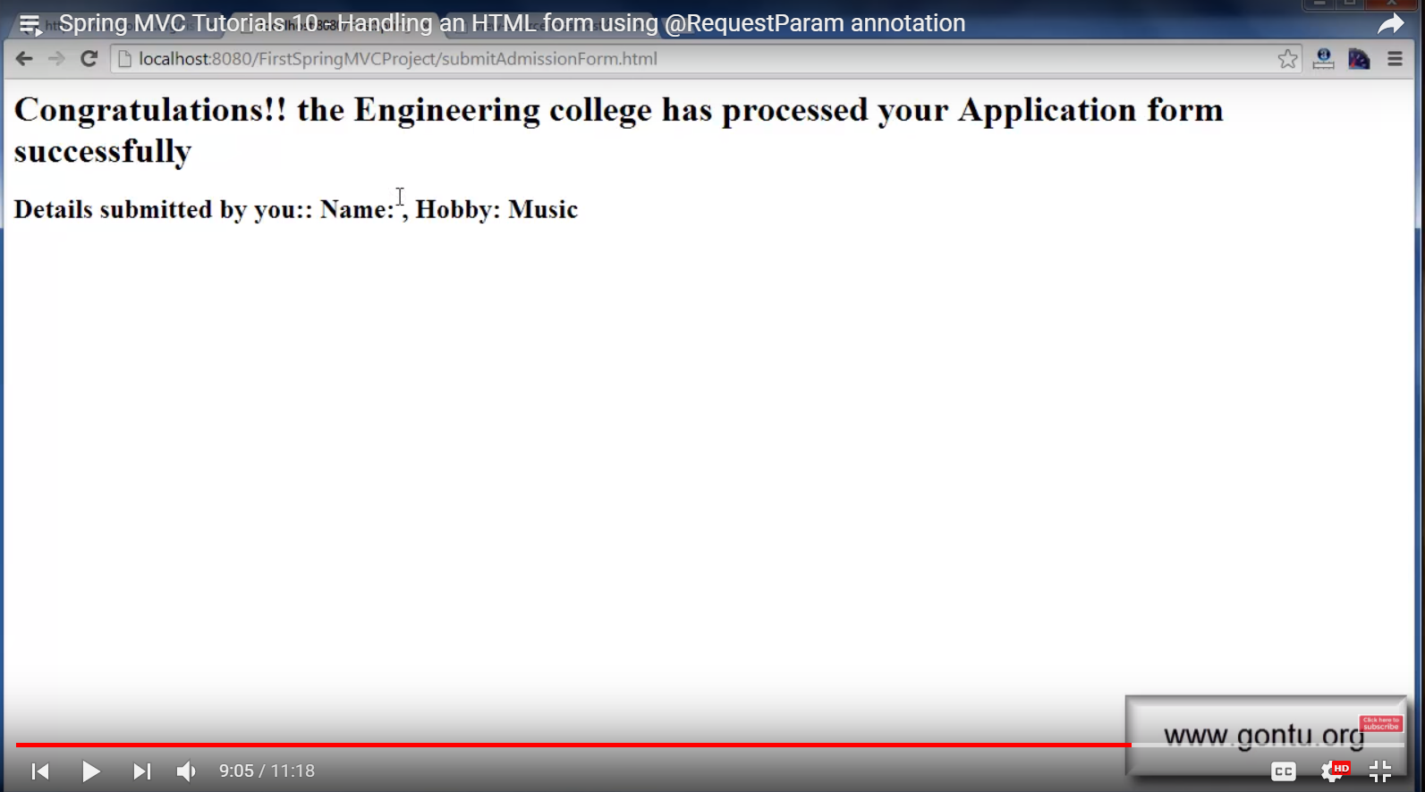

If I want to enter some default name when Client does not provide the student name, write below

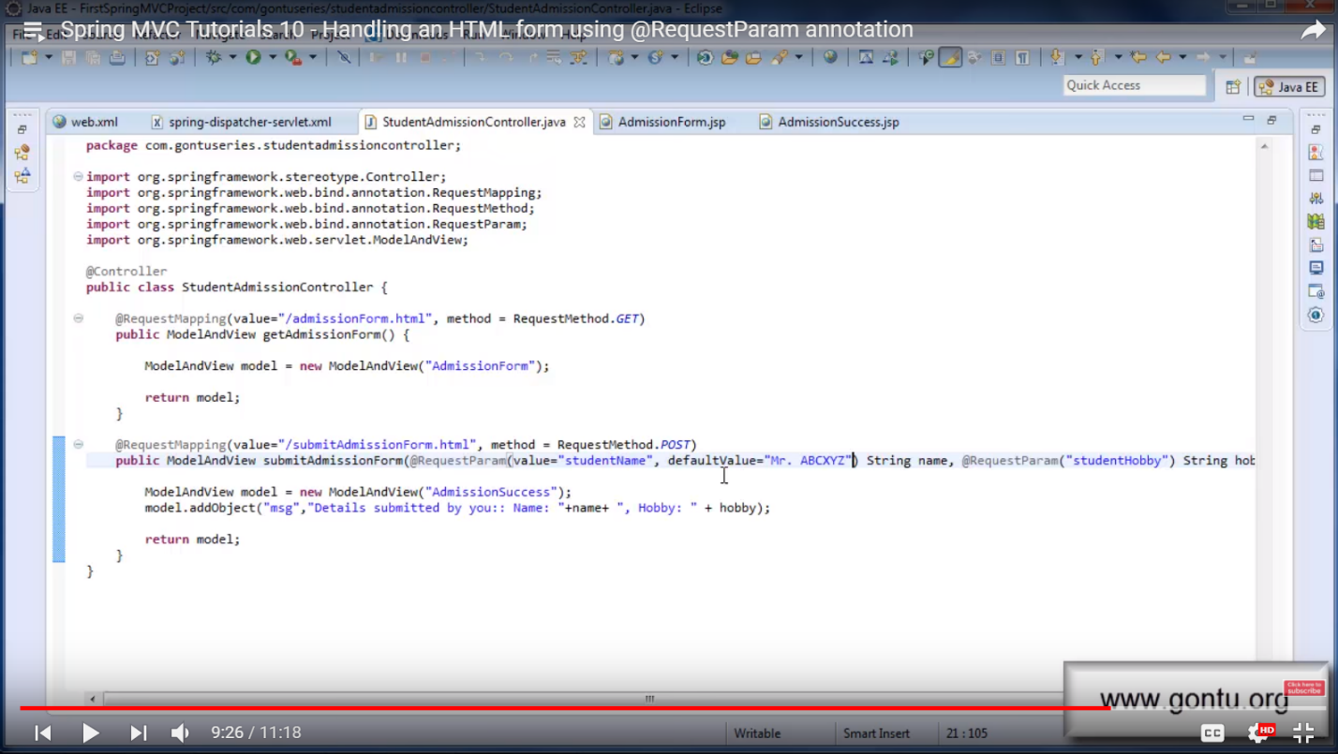

Try this out.

If there are too many @RequestParam annotation arguments then we can use a RequestParam annotation on a map as shown below:

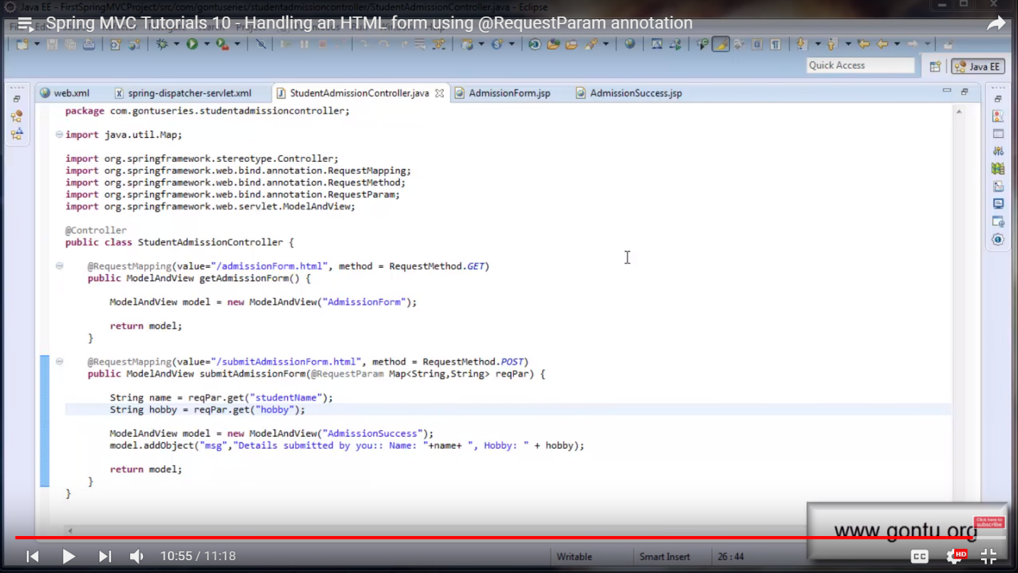

**Spring MVC Tutorials 11 – Understanding @ModelAttribute Annotation 01 (Using on a method argument)**

@ModelAttribute annotation can be used on a method or a method argument.

Create a class “Student.java” as shown below

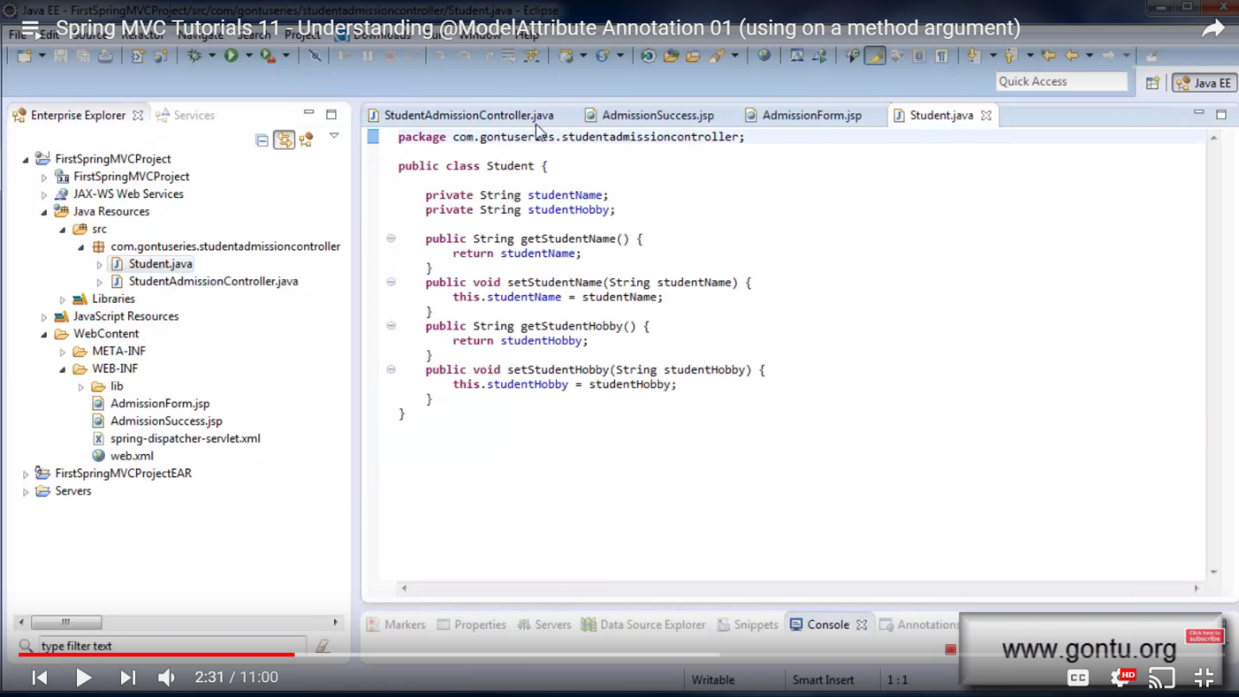

Modify “StudentAdmissionController.java” class as shown below:

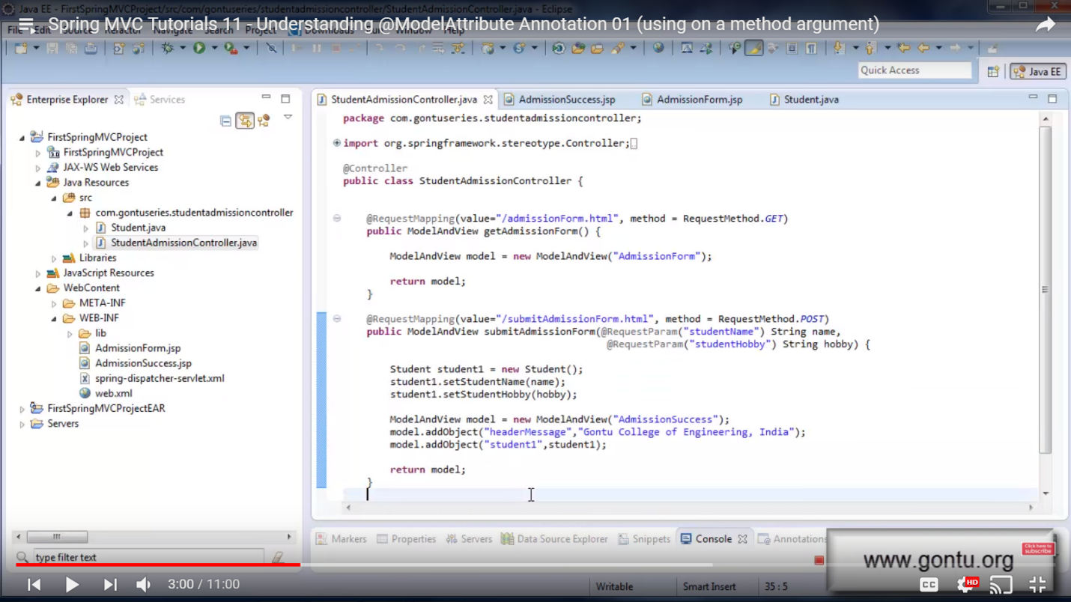  
 Modify “AdmissionSuccess.jsp” file as shown below:

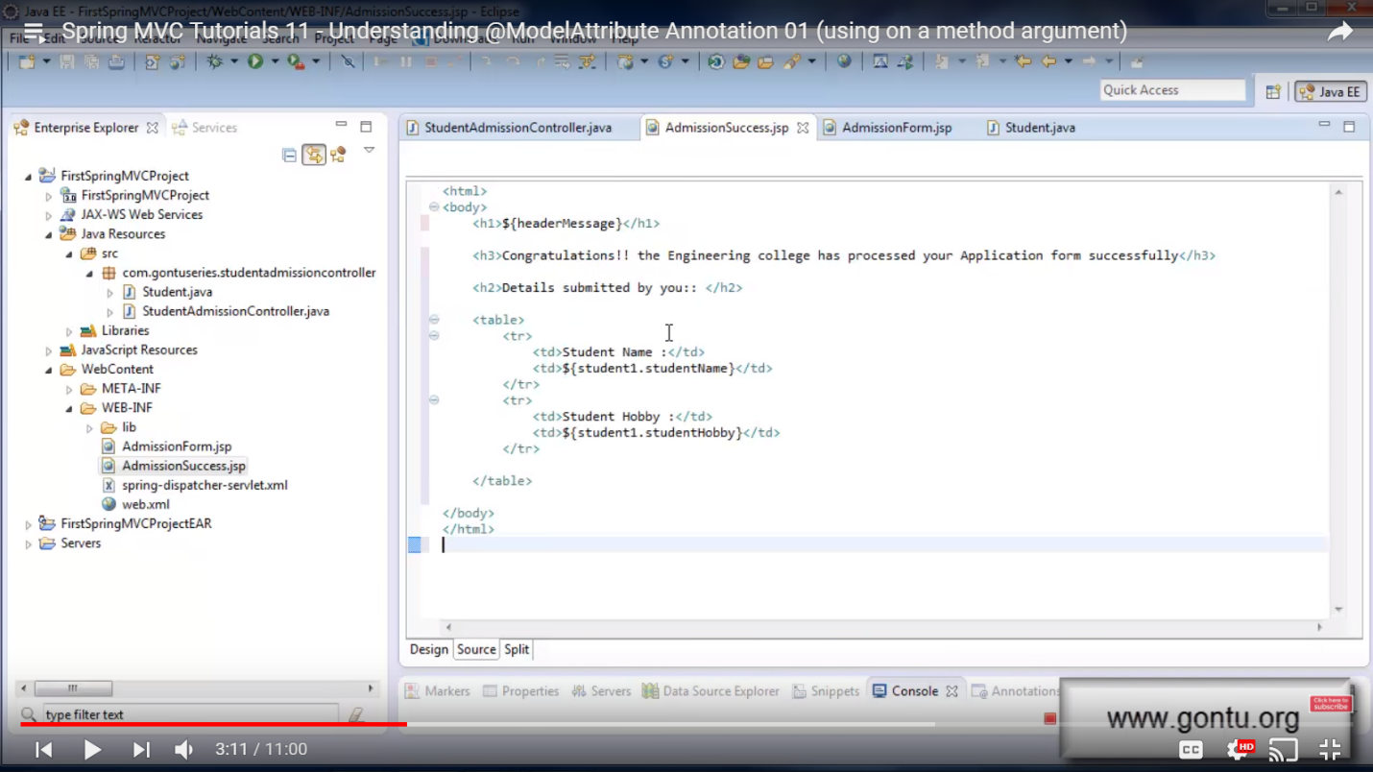

There are 2 imp things to note in “submitAdmissionForm.html” method. 1) We are binding the incoming request params values (name and hobby) with the user defined Object (Student). 2) We are binding the user defined Object (student1) to the ModelAndView Object (model) using addObject. Spring MVC says this is the right way of doing things for a requirement like this. But with the use of @ModelAttribute annotation, we can avoid writing extra code as shown below:

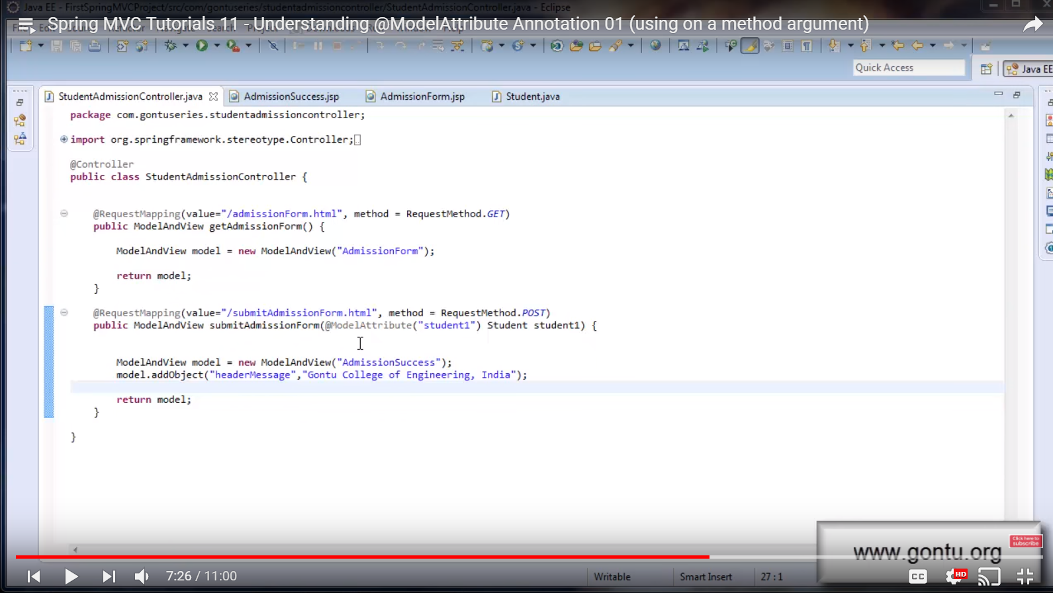

Run and verify that the application behavior is not changed.

So when I use @ModelAttribute annotation on a student object then it means that Spring MVC have extracted all request parameters and bended all request parameters with the corresponding properties of Student Object (name to name and hobby to hobby so be careful with the naming convention).

**Spring MVC Tutorials 12 – Understanding @ModelAttribute annotation 02 (using at a method level)**

Modify StudentAdmissionController.java class as shown below (added only one line):

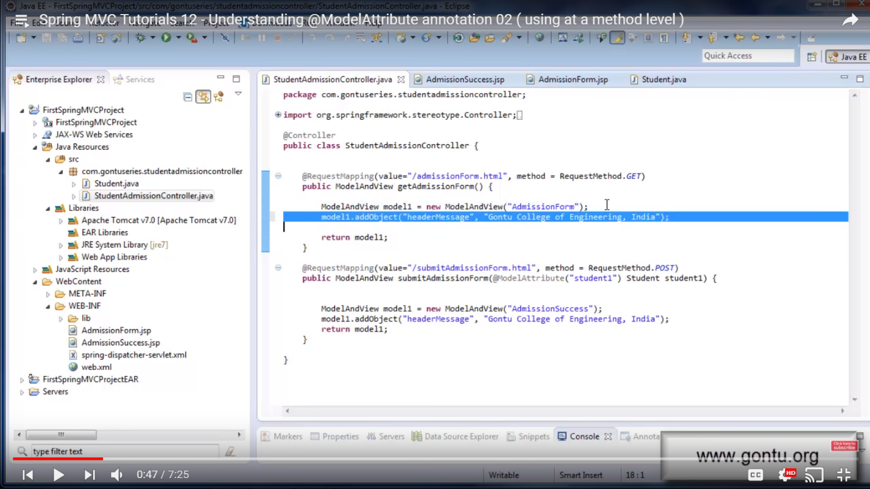

Modify AdmissionForm.jsp file as shown below (Added only one line):

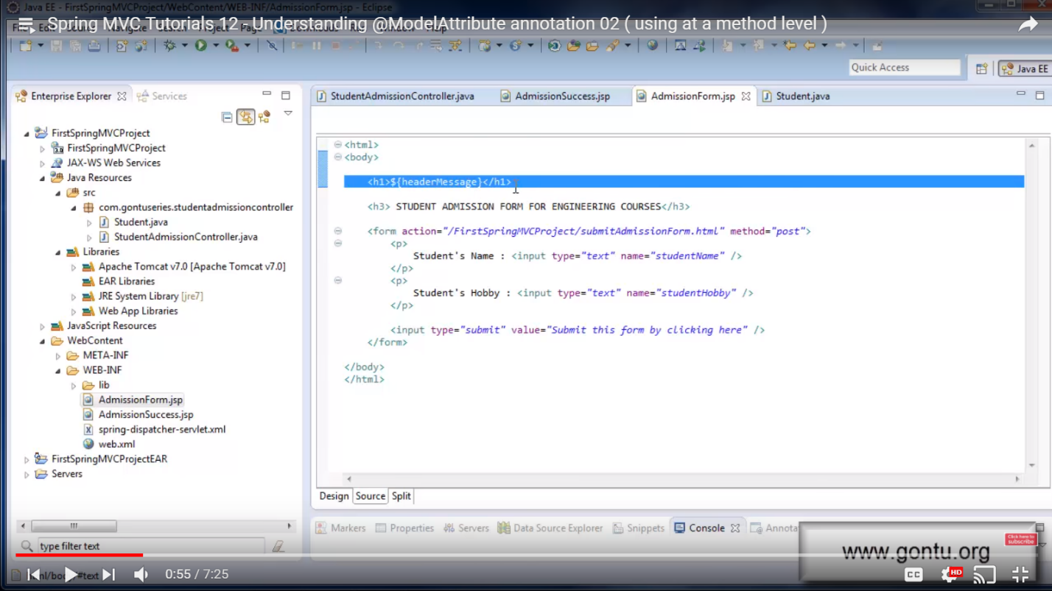

After this modification, observe StudentAdmissionController.java class. There are 2 request handler methods and both are putting same kind of object (headerMessage) in the respective ModelAndView Object. Spring MVC says if all request handler methods which are present in the same Controller class which are putting or adding same kind of object in their respective ModelAndView Object then this is the right way of doing it but we can avoid writing more code by making use of @ModelAttribute annotation on a method. This is shown below:

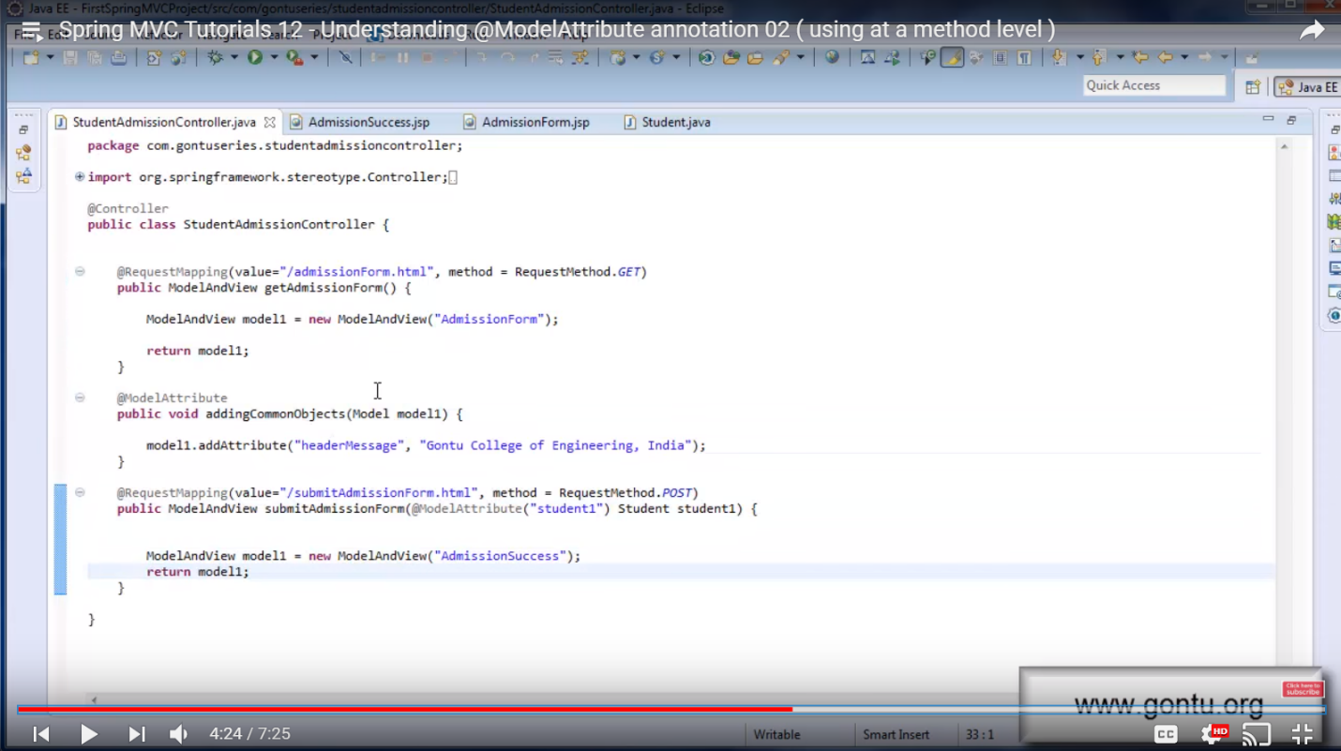

With this change, the application behavior would not change.

Note: When there is a method having @ModelAttribute annotation then Spring MVC will make a call to this method first before making a call to any of its request handler methods.

**Spring MVC Tutorials 13 – Data Binding with Date, Collection (Arraylist), Long etc.**

Modify Student.java file as shown below (new: studentMobile, studentDOB, studentSkills with getter and setter methods):

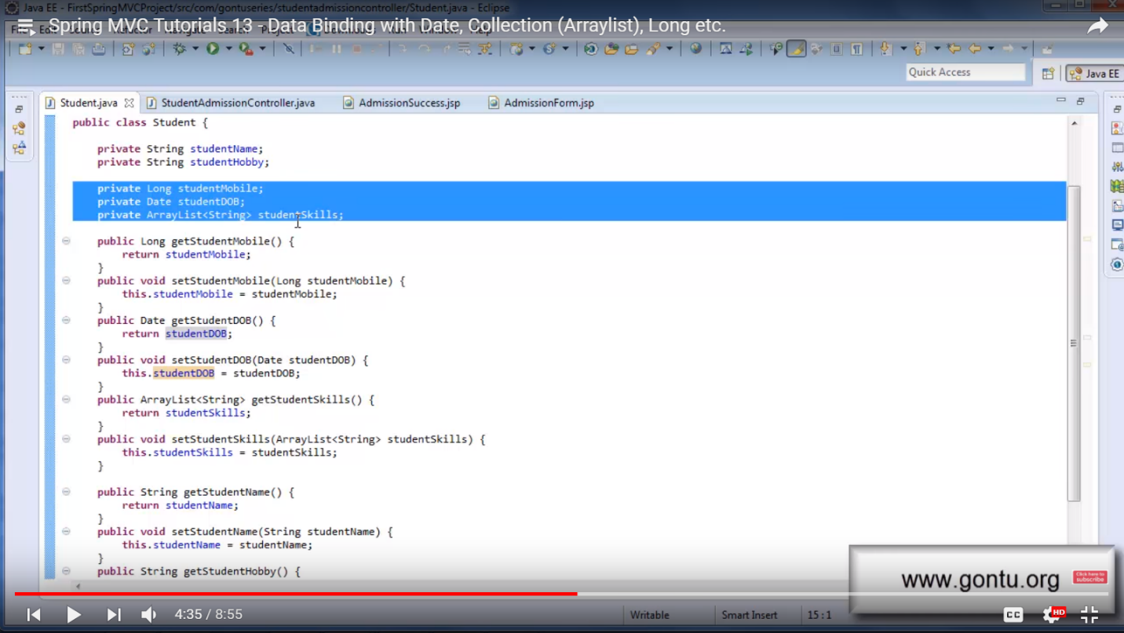

Modify AdmissionSuccess.jsp file as shown below (the highlighted text is the new addition):

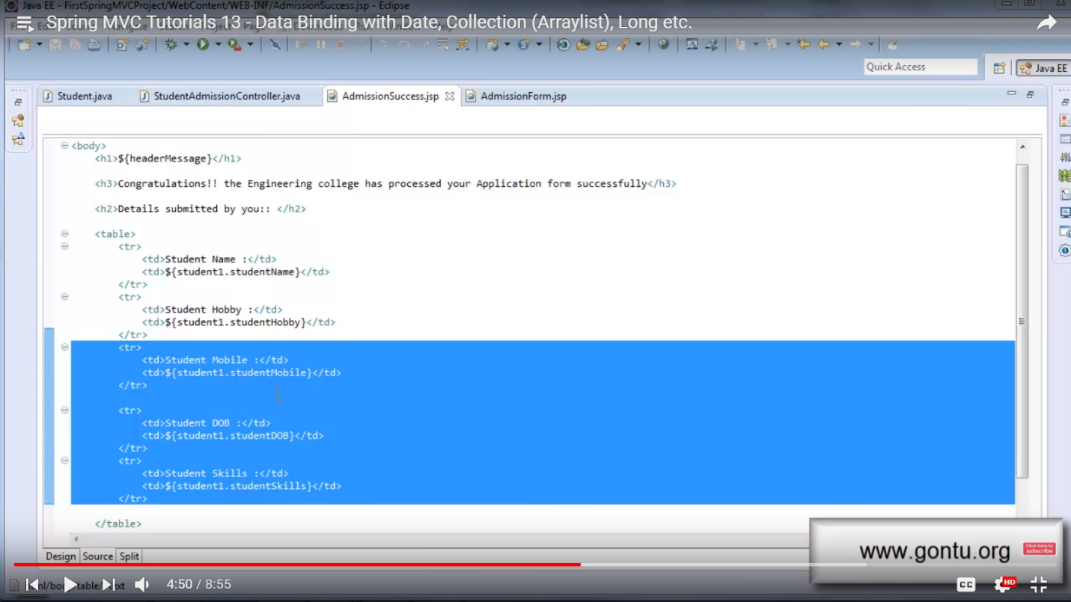

Modify AdmissionForm.jsp file as shown below (the highlighted text is the new addition):

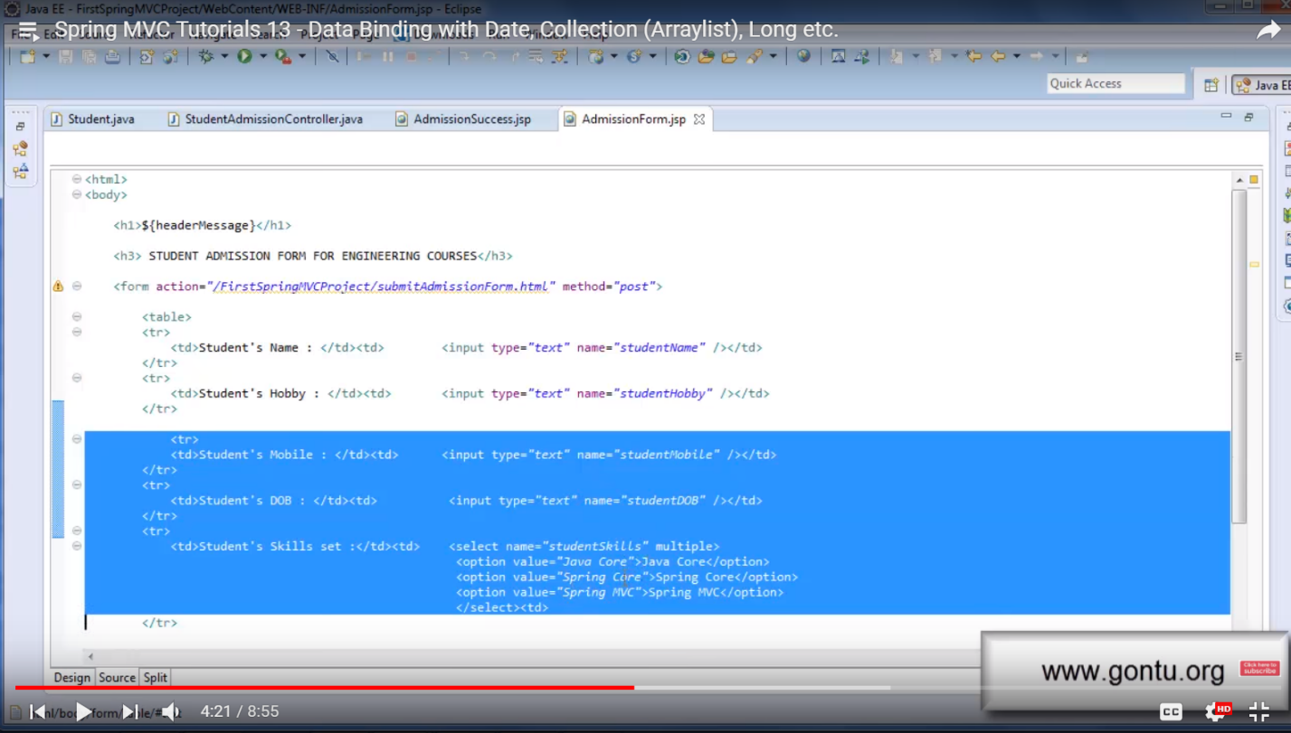

Go to the URL and enter below values:

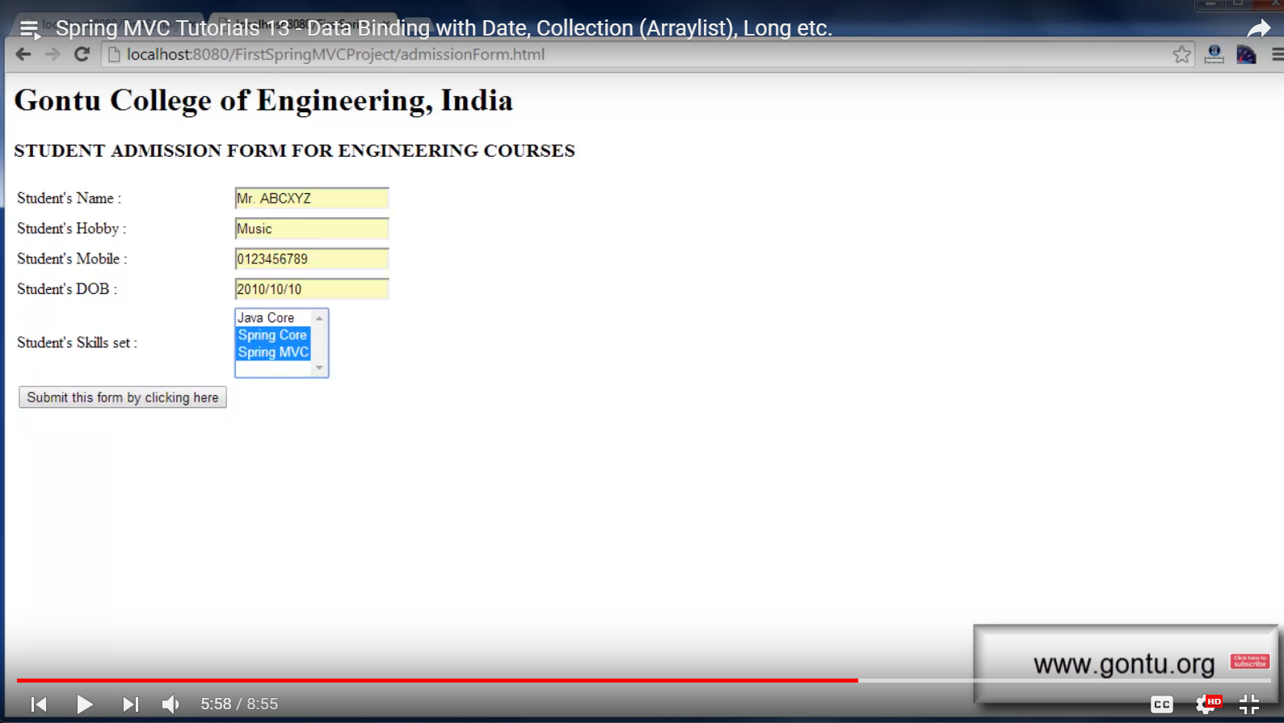

When the user clicks on the button, the request reaches the request handler method (submitAdmissionForm.html). The @ModelAttribute method will automatically bind all the request parameters with the corresponding properties of the Student Object (without worrying about the data type like we’re passing string, arraylist, date, long)

Without @ModelAttribute, we have to write lot of code as shown below:

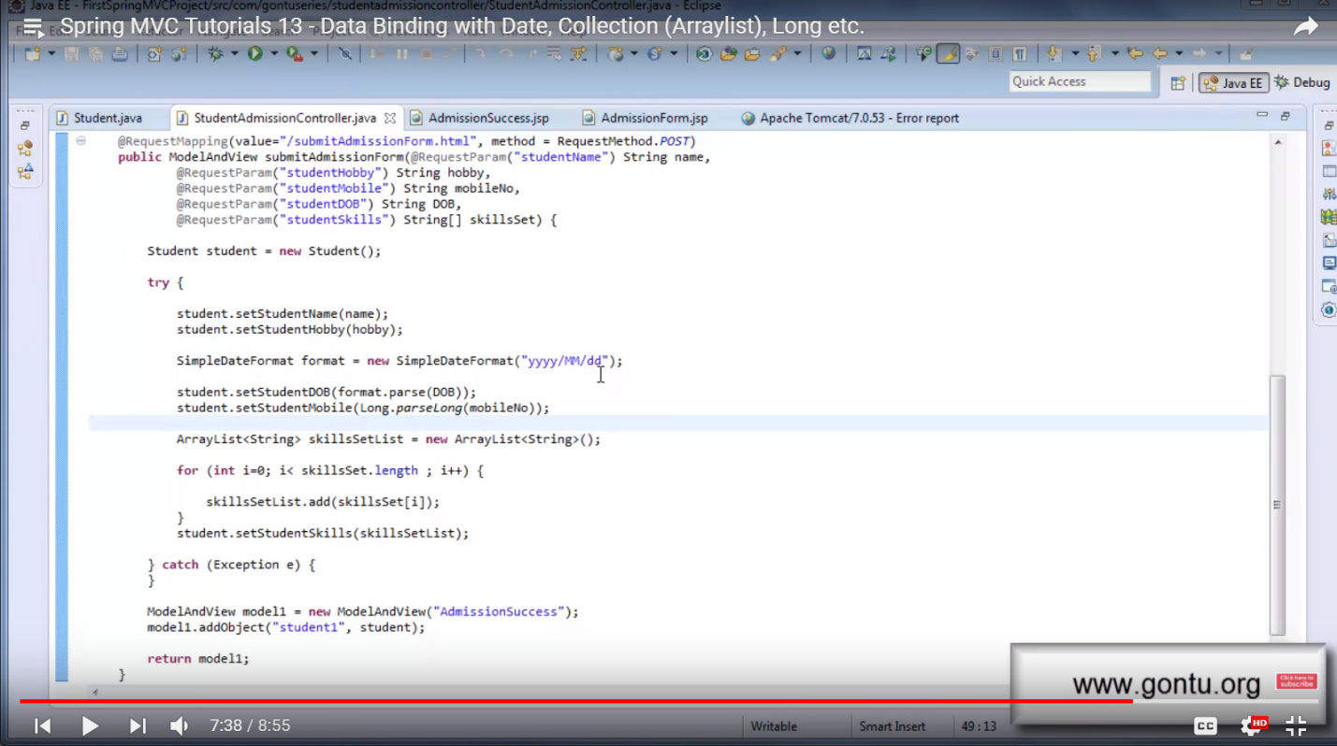

**Spring MVC Tutorials 14 – Data Binding with a User-Defined Type, BindingResult (concept)**

Here we have defined user defined object “Address” in Student.java class and learnt how Spring MVC will auto-bind complete address (like street, city, zip,..) to the corresponding object properties.

**Tutorial 18**

To keep all the custom error messages in a properties file, make use of Spring Message Source,

To make this work, include properties file and make below change in spring-dispatcher-servlet.xml file